## Working with Document Libraries in SharePoint Online

**Lab Time**: 45 minutes

**Lab Folder**: C:\Student\Modules\Documents

**Lab Overview:** In this lab you will create a new document library, work with the document library features, manage files within the library, customize the library, and save the library as a template.

### Exercise 1: Creating Document Libraries

In this exercise, you will create a few different document libraries that will be configured to use specific document types. You will also create a Picture Library that will be used to store images.

#### Log in to SharePoint Online Site

1. Make sure you have the login information for the SharePoint environment where you will work on your lab exercises. You should have received this log in information from the hosting training company or from your instructor.
2. Make sure you have the URL to the **Team Site** that has been created for you to do your lab work. This URL will be in a form that looks something like this.

https://cptclassroom101.sharepoint.com/sites/Student_Teamsite

1. Launch Internet Explorer and navigate to the URL of the Team Site mentioned in the previous step. Note that you should be logged in with a user account that has full control and access to the site collection, and therefore will be permitted access and be able to create lists.
   1. When prompted to login, enter the user name and password that has been supplied to you and then click **OK**.

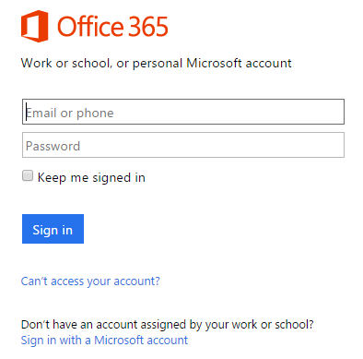

* 1. You should be able to confirm that you are logged into the SharePoint site. For example, if you were logged in as a student named **CPT Student**, your name would appear in the SharePoint Welcome menu as shown in the following screenshot.

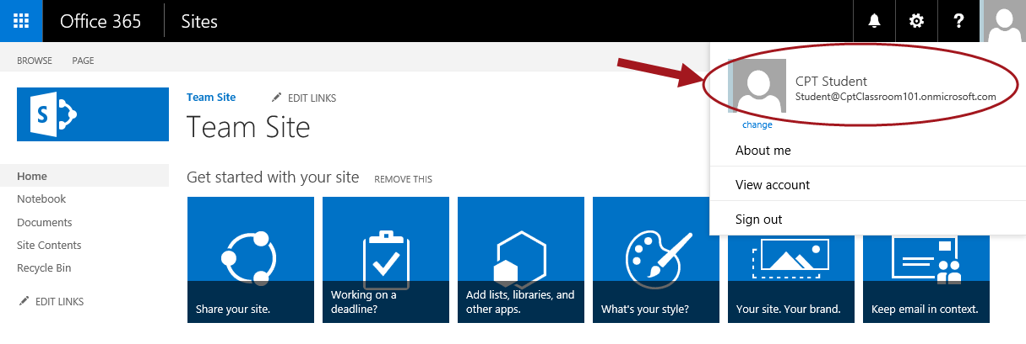

#### Create a Word Document Library

In this part of the exercise you will create a Document Library to hold Word documents.

1. To create a new Document library, click on the **Settings** icon then click **Add an app**.

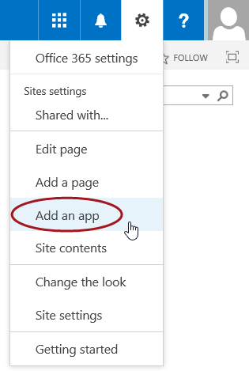

1. Click on the **Document Library** tile.

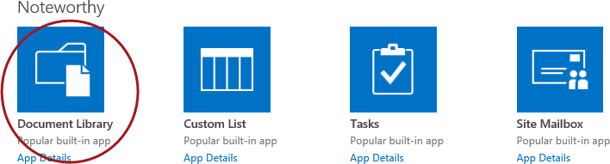

1. The Adding Document Library popup dialog will appear. In the **Name** text box, type **Word Documents** and then click **Create**.

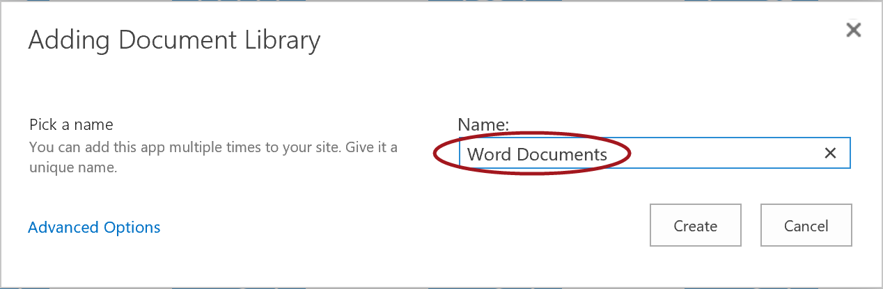

1. The library will be created and you will be redirected to the Site Contents page which will display the new Word Documents tile. Click on the **Word Documents** tile to open the library.

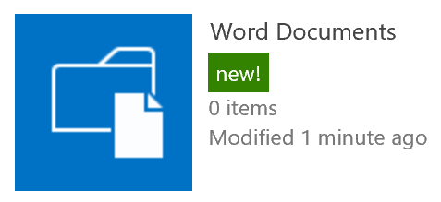

1. The **Word Documents** library will now display in the default All Documents view and the library will be empty.

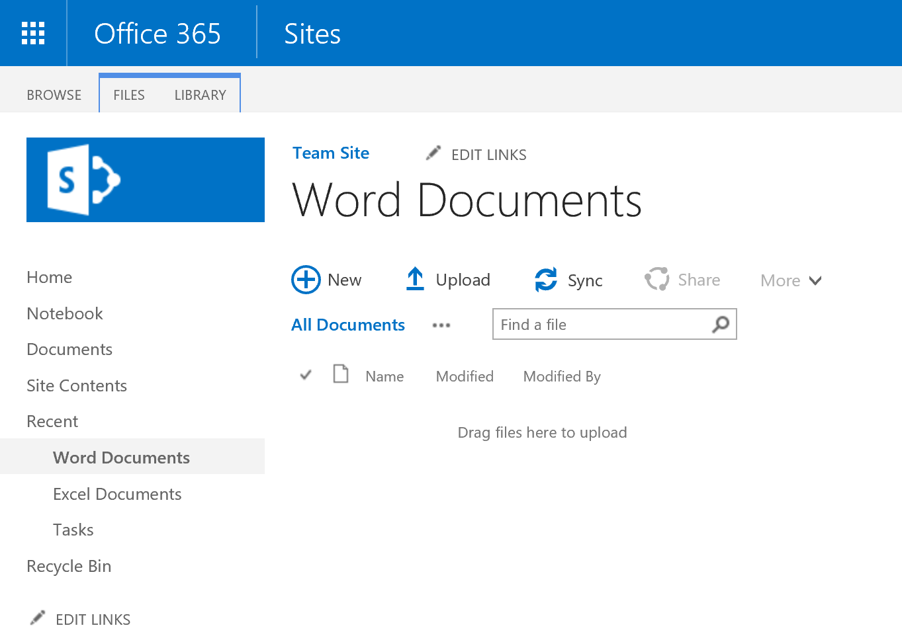

1. Proceed to the next steps to create an Excel Document Library.

#### Create an Excel Document Library

1. To create a new Document library, click on the **Settings** icon then click **Add an app**.



1. Click on the **Document Library** tile.



1. From the dialog, click the **Advanced Options** link.

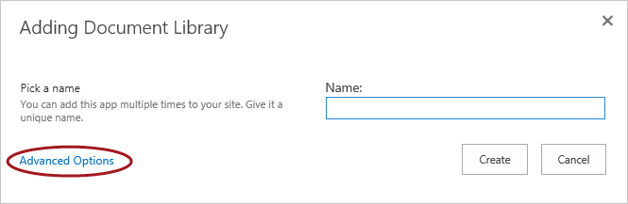

1. You will now be on the Advanced Options create page. Proceed with the following settings:
   1. In the **Name** text box from the popup dialog, type **Excel Documents** and type something for the **Description** (optional).

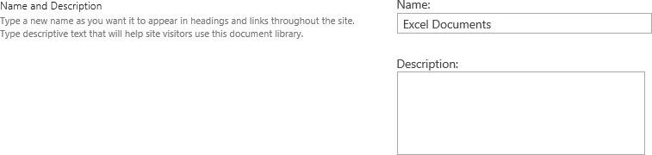

* 1. Leave the **Document Version History** setting for **Create a version each time you edit a file in this document library** set to **Yes**.



* 1. In the **Document Template** drop-down list, ensure **Microsoft Excel spreadsheet** is selected then click **Create**.

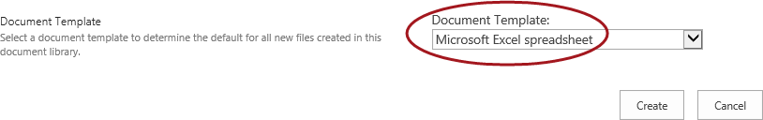

1. The **Excel Documents** library will now display in the default All Documents view with the **LIBRARY** tab automatically selected.

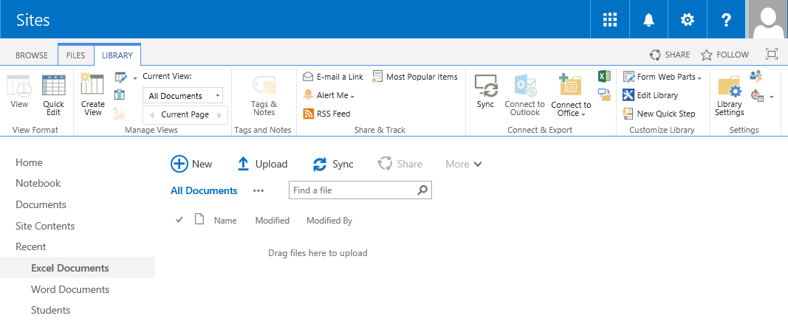

Because **Microsoft Excel Spreadsheet** was selected in the **Document Template** option in the previous step, the library is using a blank Excel template. The options for Create a new file options will only include **New Document** (Excel) and **New Folder**. The screenshot below illustrates these options. Later in this lab, you will modify the default template that this library is using.

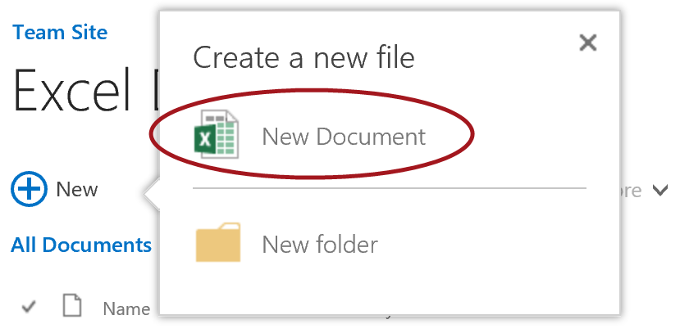

1. Proceed with the next steps to create a new Picture Library.

#### Create a Picture Library

1. To create a new Picture library, click on the **Settings** icon then click **Add an app**.



1. To easily find the Picture Library template, type **Picture** in the **search box** located between Site Contents > Your Apps and the Noteworthy tiles then click on the **search icon**.

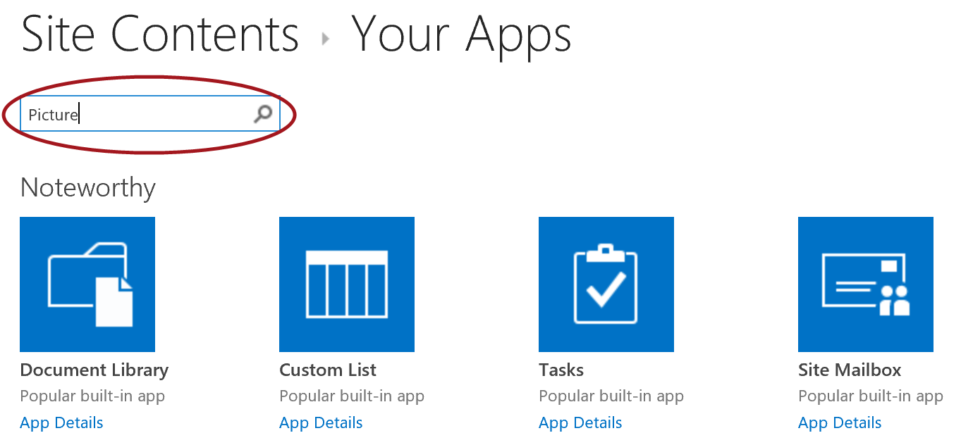

1. Now click on the **Picture Library** tile.

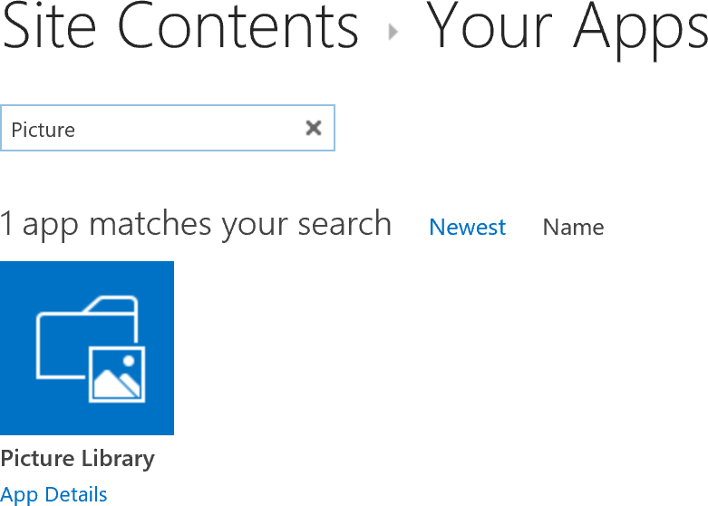

1. The Adding Picture Library popup dialog will appear. In the **Name** text box, type **Employee Photos** and then click **Create**.

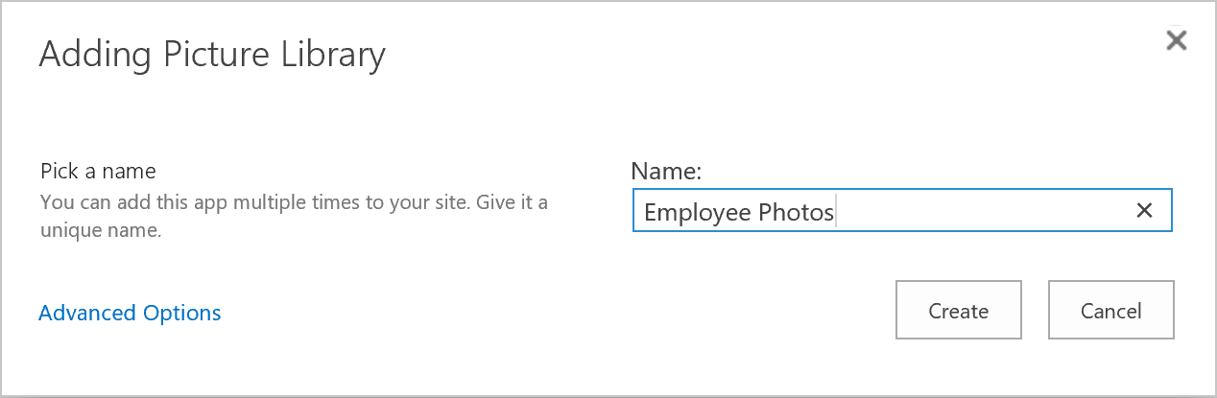

1. The library will be created and you will be redirected to the Site Contents page which will display the new Employee Photos tile. Click on the **Employee Photos** tile to open the new library.

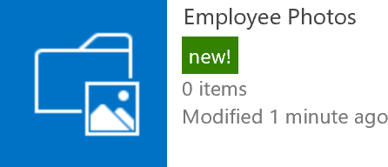

1. The **Employee Photos** picturelibrary will now display in the default Thumbnails view and the library will be empty.

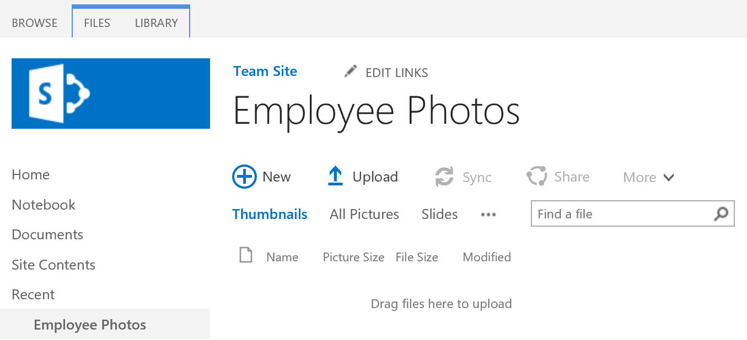

1. Proceed to the next steps to create and manage files.

### Exercise 2: Creating and Managing Files in Document Libraries

In this exercise, you will create documents and folders, upload documents, open the library in Explorer View, and move files between SharePoint folders and document libraries.

#### Upload Files to Picture Library

In this section, you will upload photos to the **Employees Photos** picture library you created in the previous steps.

1. Upload existing documents:
   1. Open Windows Explorer and navigate to **C:\Student\Modules\Documents\Lab\Employee Photos**.
   2. Select all the files in the folder.
   3. Hold down your mouse button and drag the files from Windows Explorer to the **Employee Photos** library as shown in the image below. Then release the mouse button.

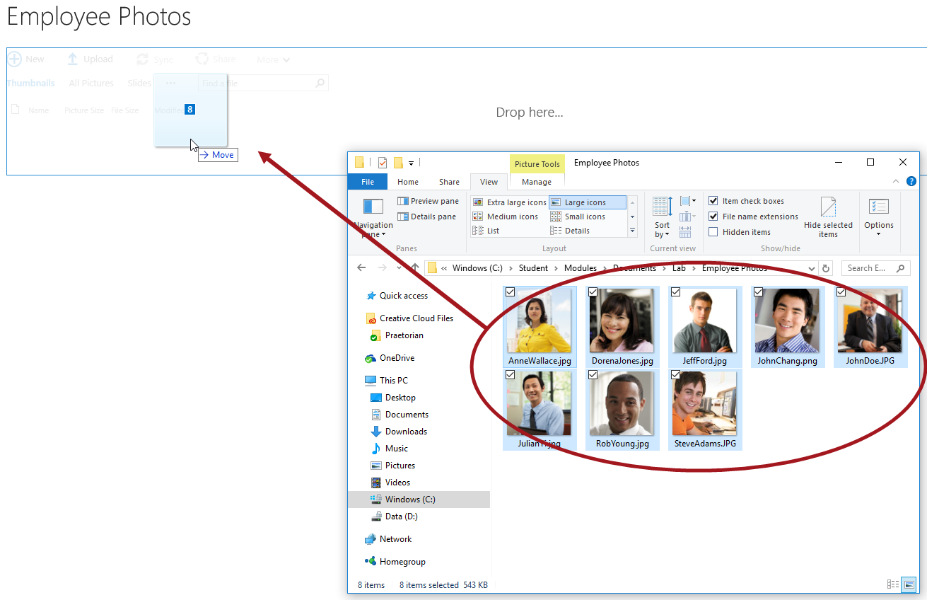

1. The documents will begin uploading and a progress bar and progress icons will show up on the page during the upload.

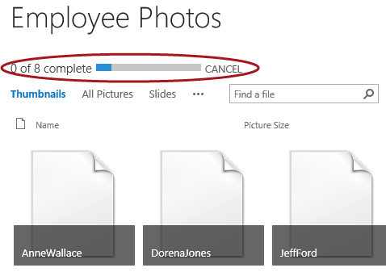

1. Once the upload process is done, the photos will show up in the library as tiles.

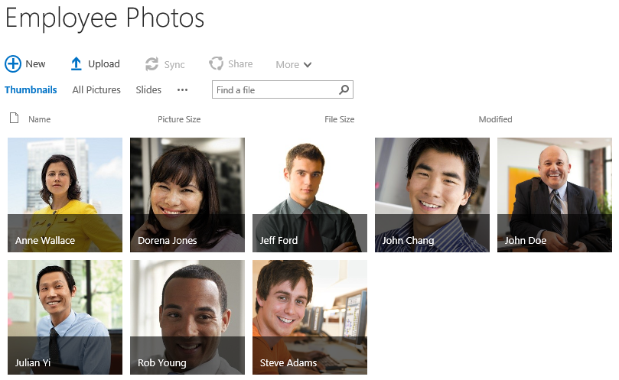

#### Create New Word Document

In this section, you will create a new Word document in the document library titled **Word Documents** and use Word Online to modify the file. Note: This library is using a blank Word template file as the default template which can be modified and you will do so later in this lab.

1. Open your Word Documents library.
   1. Navigate to **Site Contents** then click on the **Word Documents** tile.
2. Click on **+New** in the **Word Documents** library.

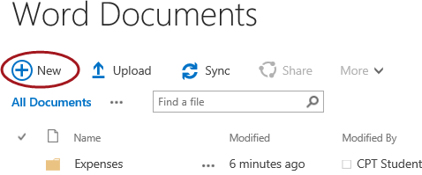

1. A modal dialog will appear with a list of options. Click on **Word document**.

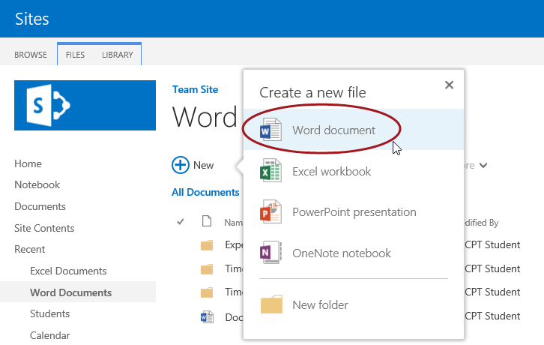

1. The document will be created and will open in Word Online.

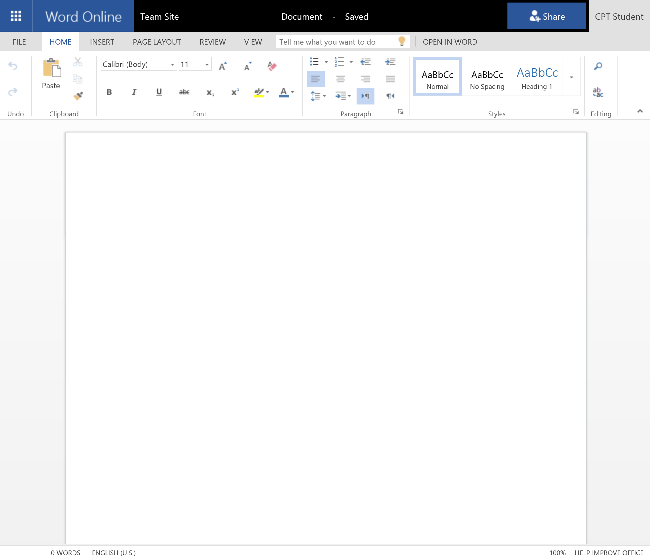

1. To rename the document, click on the **Document** name as indicated in the image below and type **Project Status**. The document will automatically be saved in SharePoint.

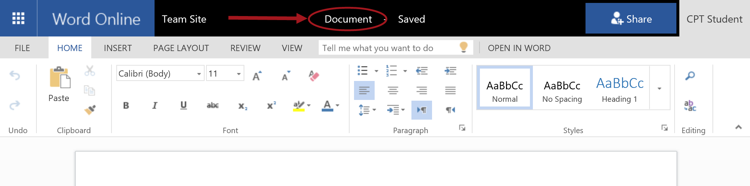

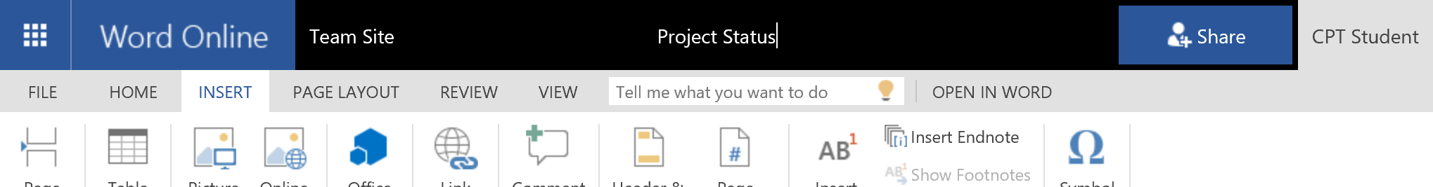

1. Place your cursor inside the document then click on **Heading 1** located in the styles ribbon group.

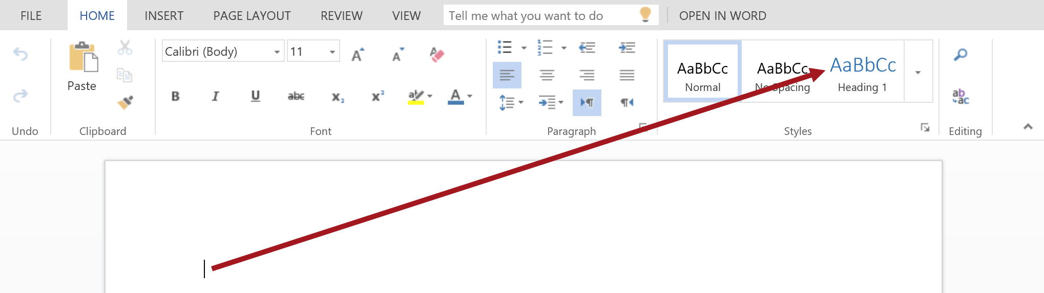

1. Type **Project Status**, hit enter and then add more text to your document. The file will automatically save.

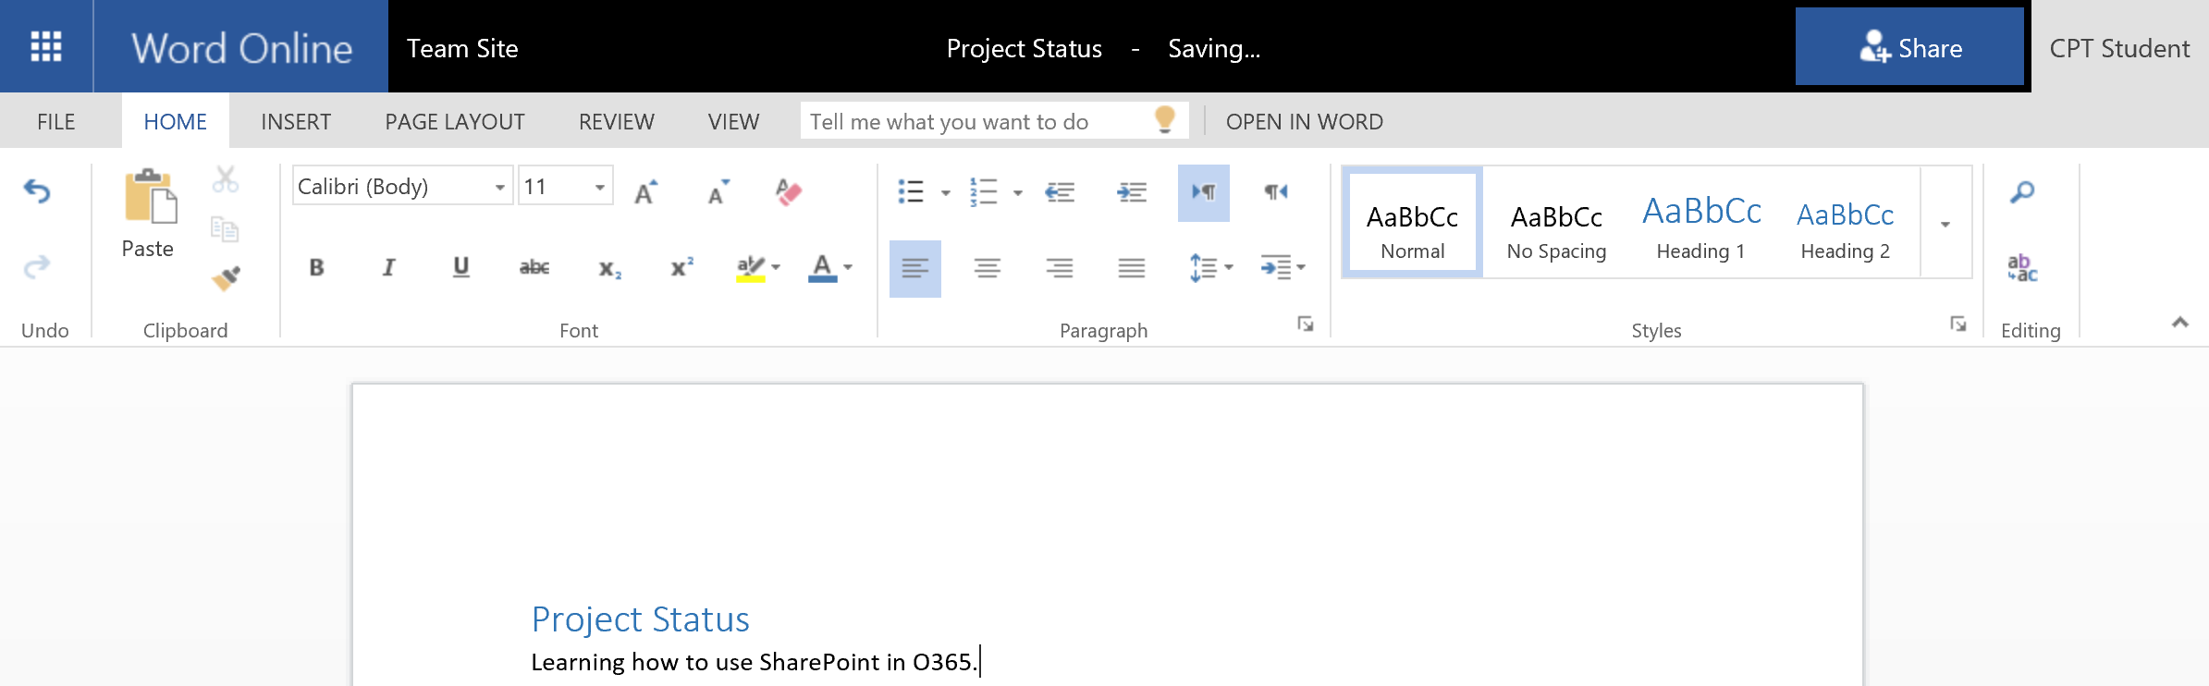

1. To navigate back to the Word Documents document library, click on **Team Site** located to the left of the filename.

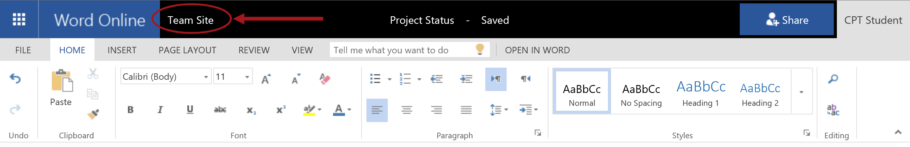

1. You will be redirected back to your document library and you should now see your newly created Project Status file.

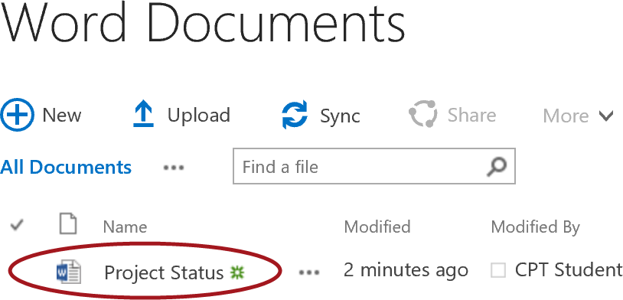

#### Create New Excel Document

In this section, you will create a new Excel document in the document library titled **Excel Documents** and use Excel Online to modify the file. Note: This library is using a blank Excel template file as the default template which can be modified and you will do so later in this lab.

1. Open your Excel Documents library.
   1. Navigate to **Site Contents** then click on the **Excel Documents** tile.

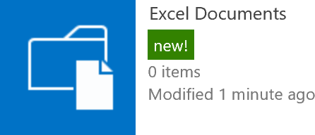

1. Click on **+New** in the **Excel Documents** library. A modal dialog will appear with a list of options. Click on **New Document**.

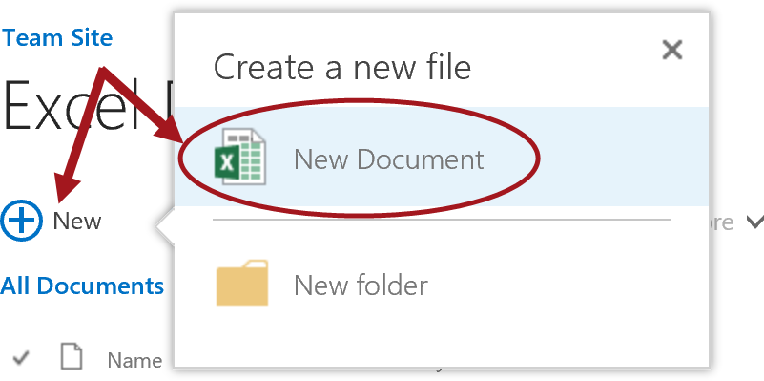

1. The excel document will be created and opens in Excel Online.

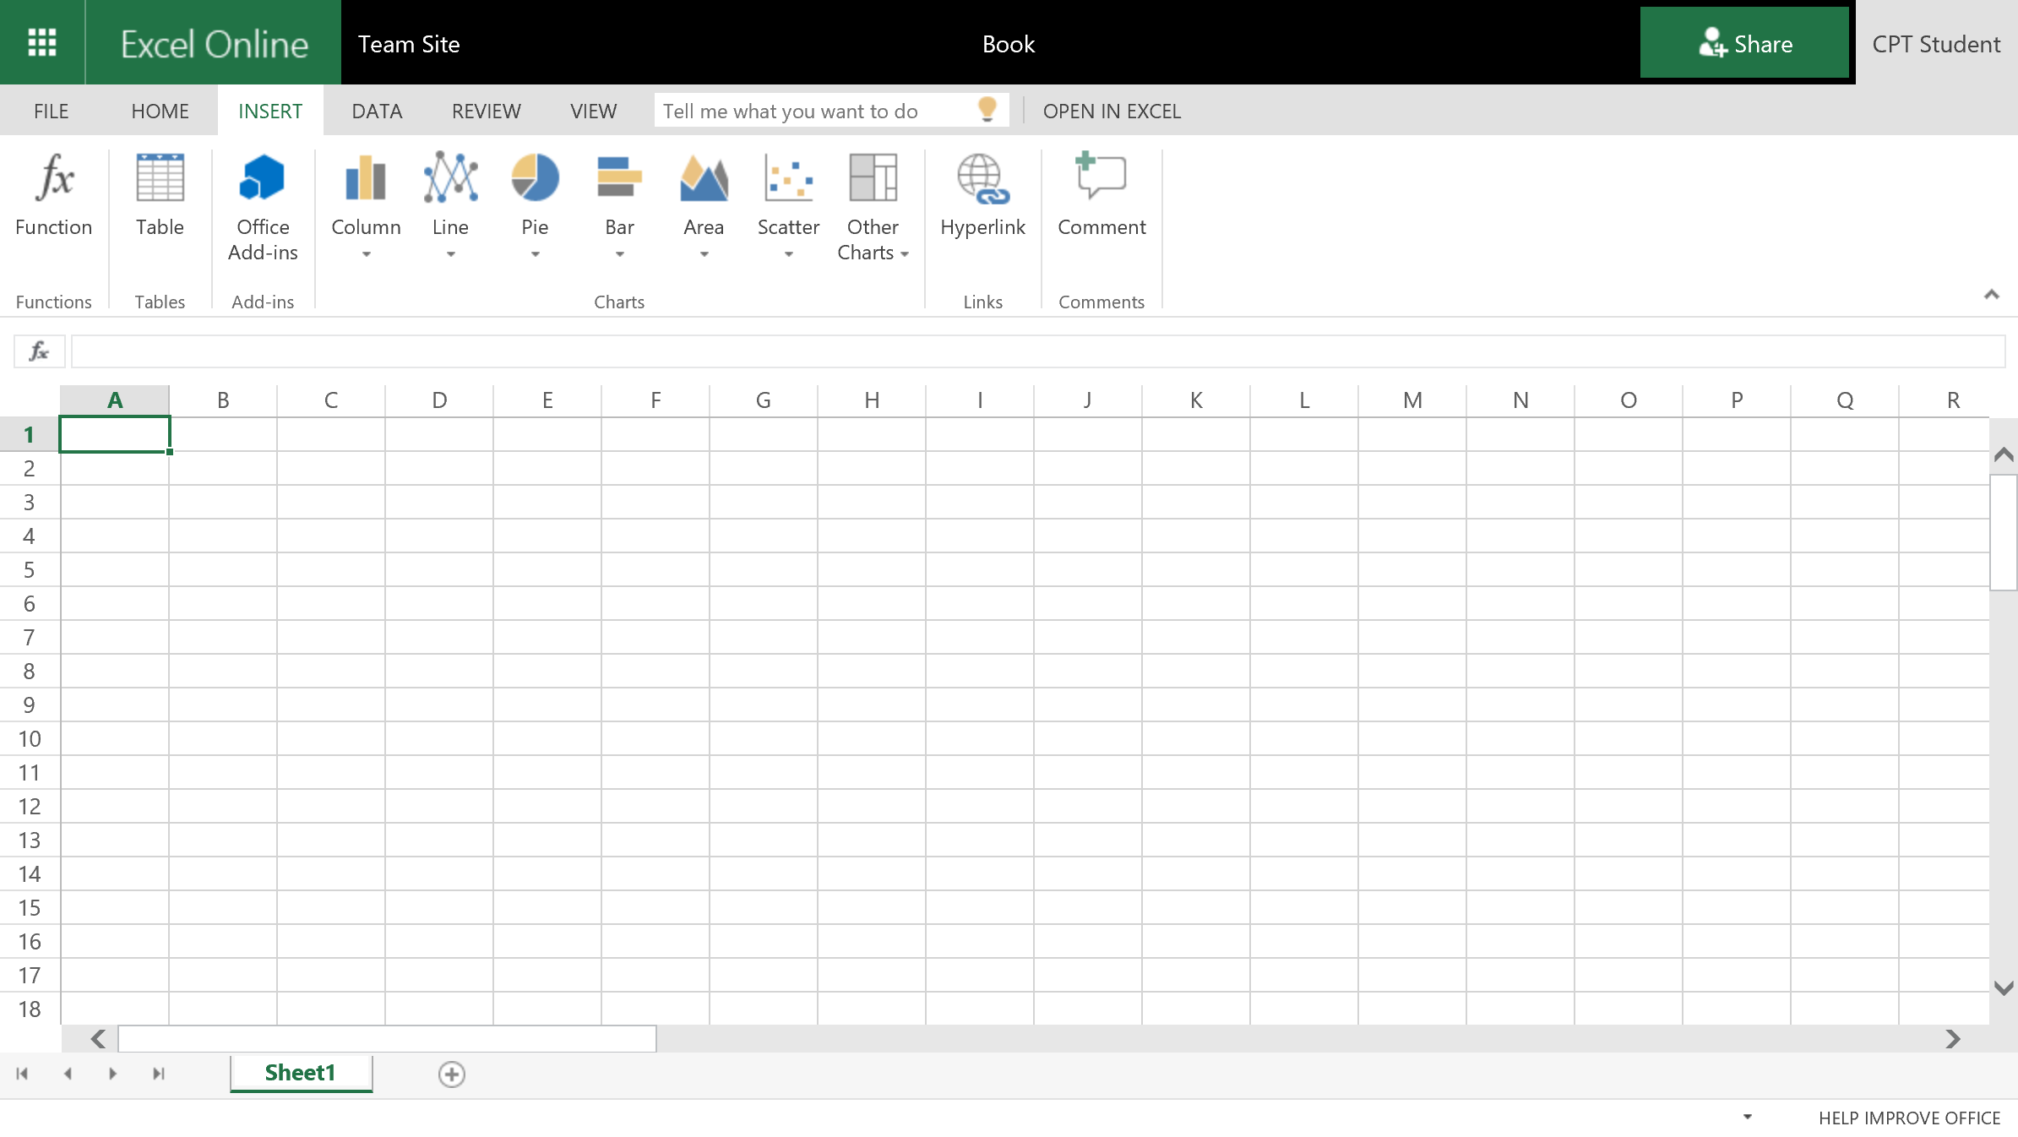

1. To rename the document, click on the **Book** name as indicated in the image below and type **Project Milestones**.

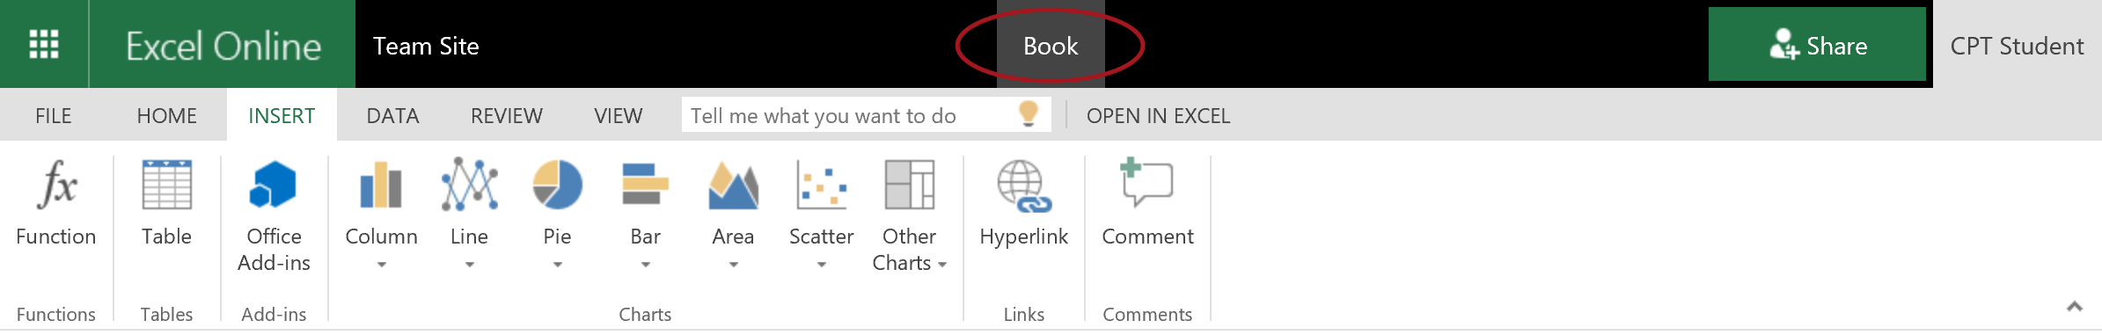

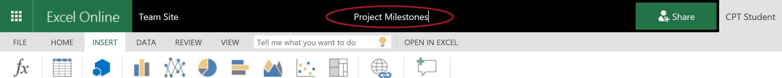

1. Now add some data to the document.

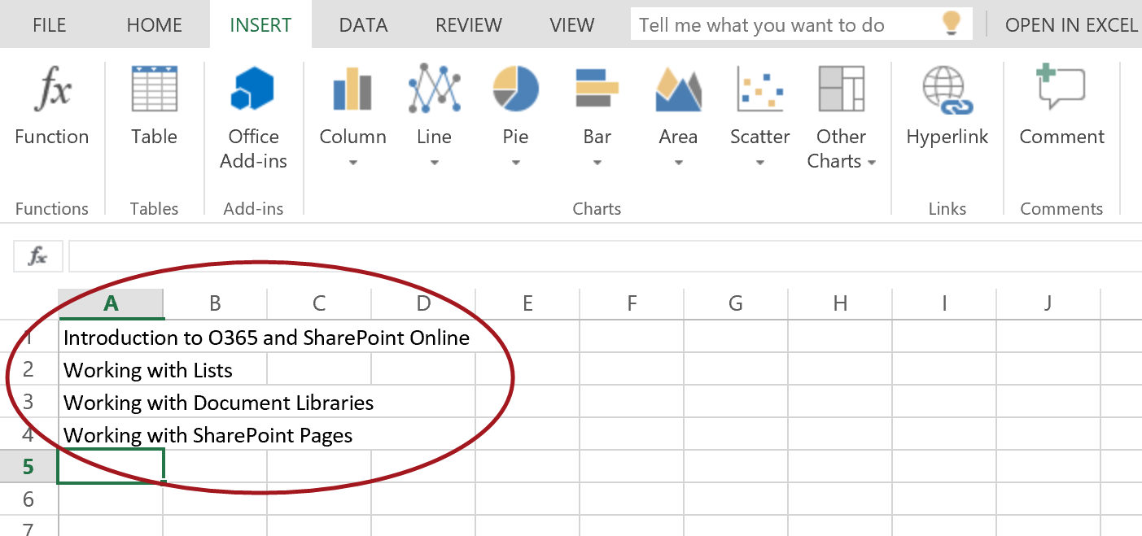

1. Rename Sheet 1 to Milestones:
   1. Right-click on the **Sheet 1 tab** then choose **Rename…**

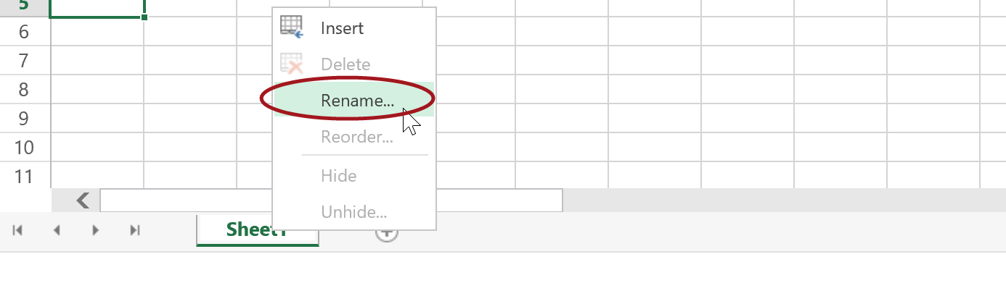

* 1. Type **Milestones** then click **OK**.

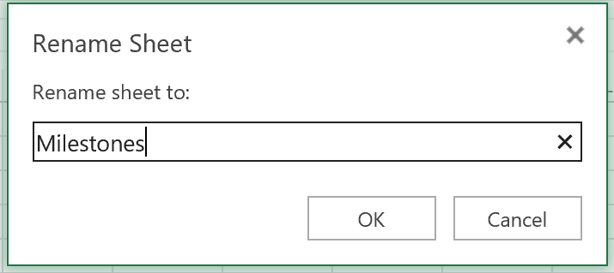

* 1. The sheet is now renamed to Milestones.

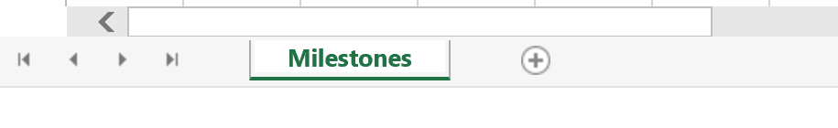

1. To navigate back to the Excel Documents document library, click on **Team Site** located to the left of the filename.

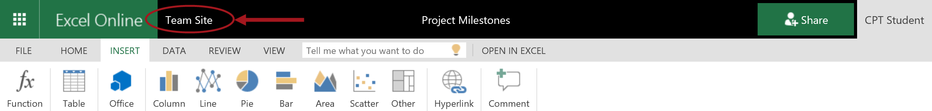

1. You will be redirected back to your document library and you should now see your newly created Project Milestones excel file.

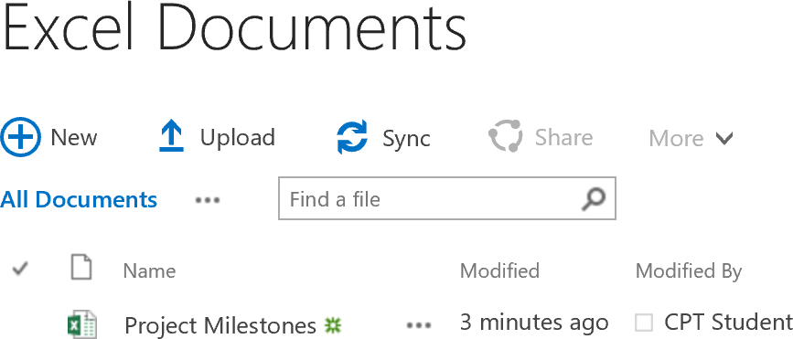

#### Upload Files to Document Library

In these steps, you will upload some existing files to the out-of-the-box document library titled **Documents**.

1. Open your Documents library.
   1. Navigate to **Site Contents** then click on the **Documents** tile or click on the **Documents** link located in the Quick Launch.

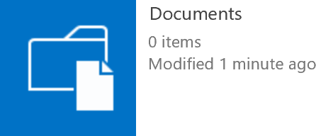

1. Upload existing documents:
   1. Open Windows Explorer and navigate to **C:\Student\Modules\Documents\Lab**.
   2. Select all the documents that are outside of the Templates folder. Do not include the Templates folder.
   3. Hold down your mouse button and drag the files from Windows Explorer to the **Documents** library as shown in the image below. Then release the mouse button.

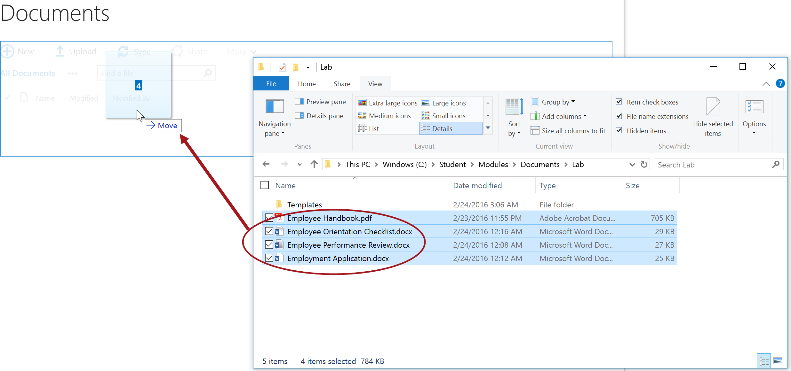

1. The documents will begin uploading and a progress bar and progress icons will show up on the page during the upload.

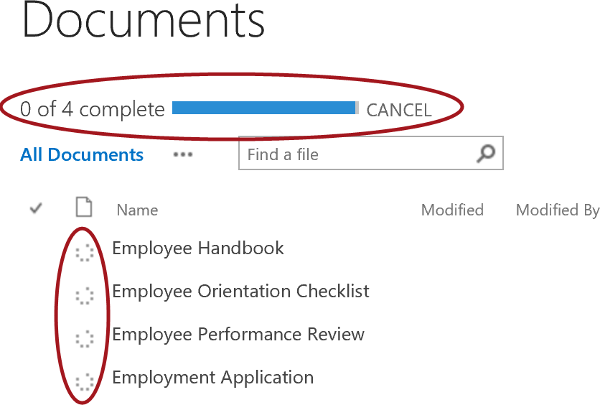

1. Once the upload process is done, the documents will show up in the library and the document icon will display next to each document based on the document type.

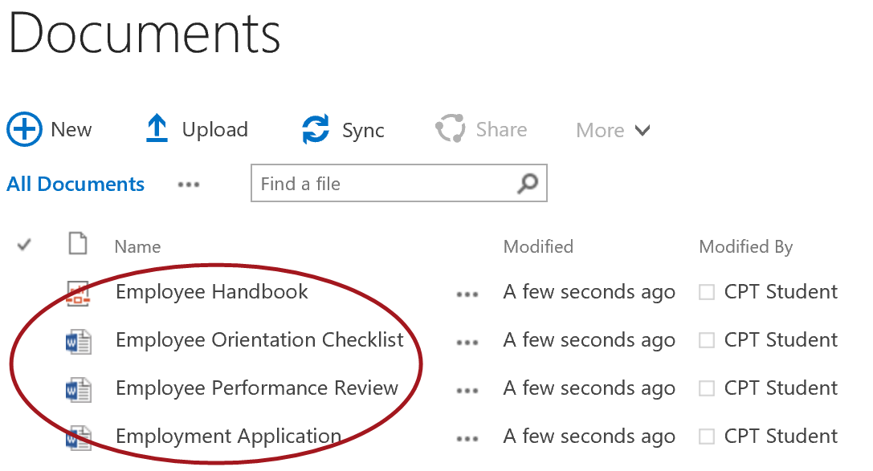

#### Create New Folders

In this section, you will continue to work in the existing Documents library. You will create 3 folders for this document library titled Employees, HR Only, and Manager Only Forms.

1. Create a new folder called Employees:
   1. Click on **+New** in the **Documents** library. A modal dialog will appear with a list of options. Click on **New Folder**.

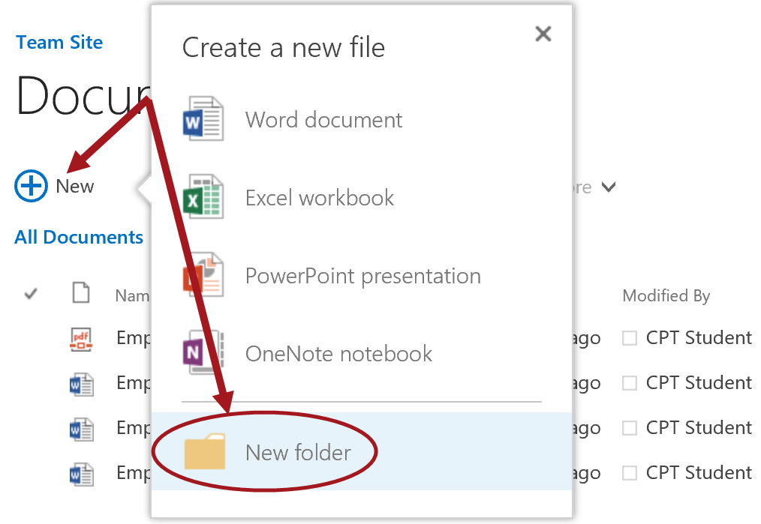

* 1. In the **Name** text box, type **Employees** and then click **Create**.

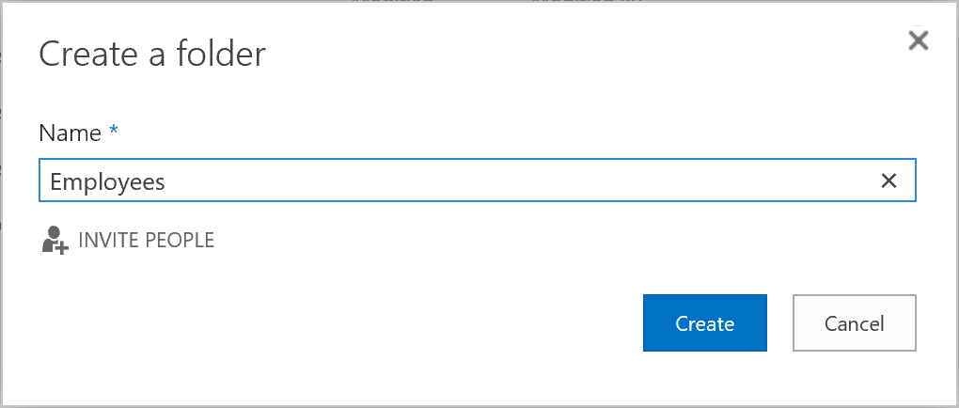

1. Repeat the steps above to create the remaining folders titled **HR Only** and **Manager Only Forms**.

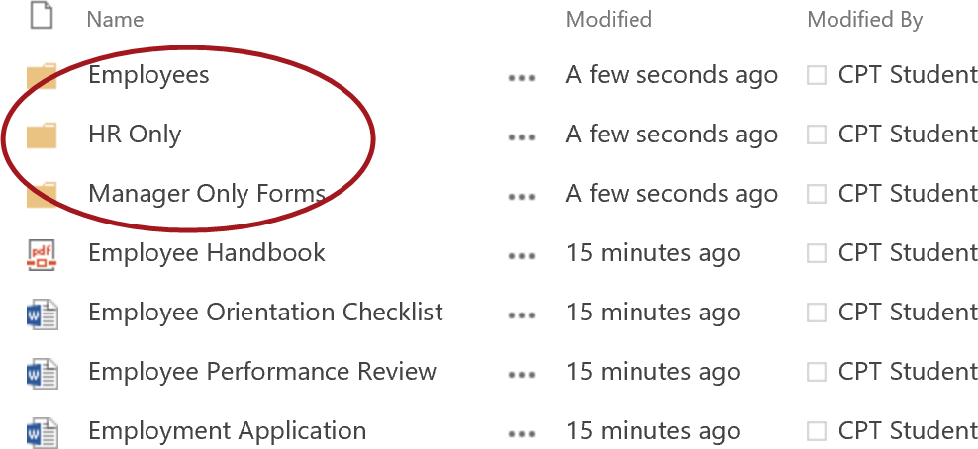

#### Move Files into Folders

In these steps, you will move the existing files into the newly created folders.

1. Move the Employee Handbook document into the Employees folder:
   1. Click on the **Employee Handbook PDF icon**, hold down the mouse button and drag the file to the **Employees** folder. Release the mouse button to move the file.

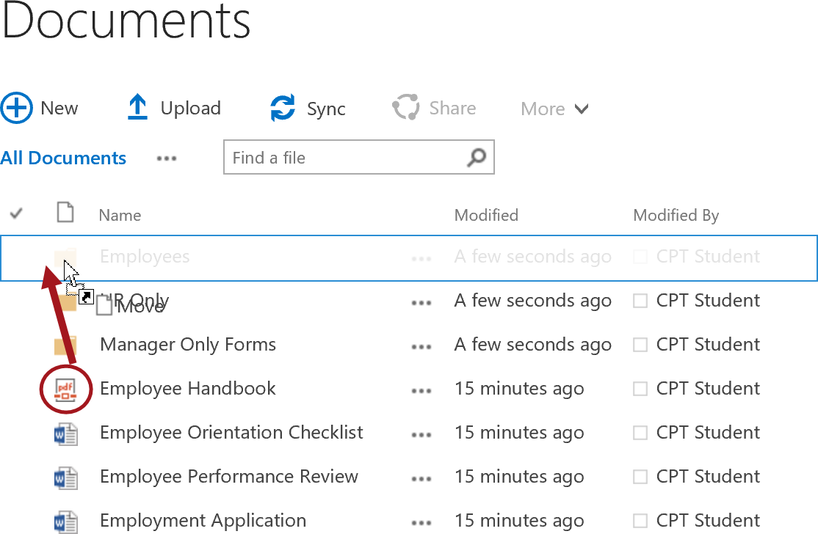

* 1. The document has now been moved into the Employees folder. Click on the **Employees** folder icon to open the Employees folder.

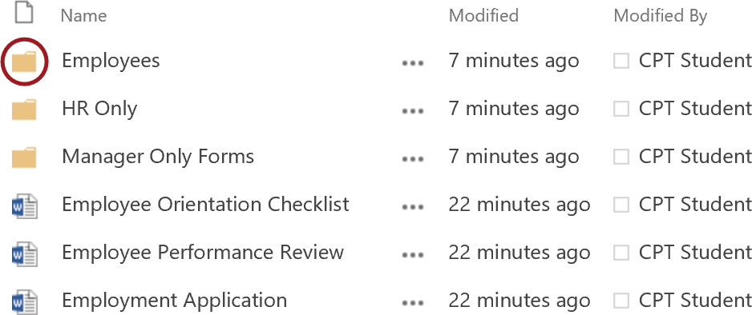

* 1. Verify the Employee Handbook pdf file is in the Employees folder.

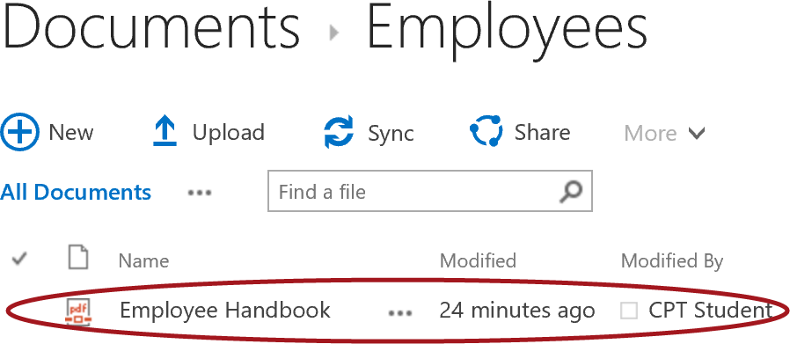

* 1. To navigate back up, click on the **Documents** link.

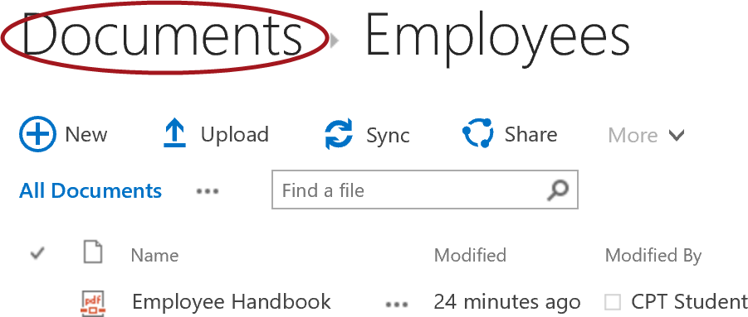

* 1. You will now be back in the root of the library.

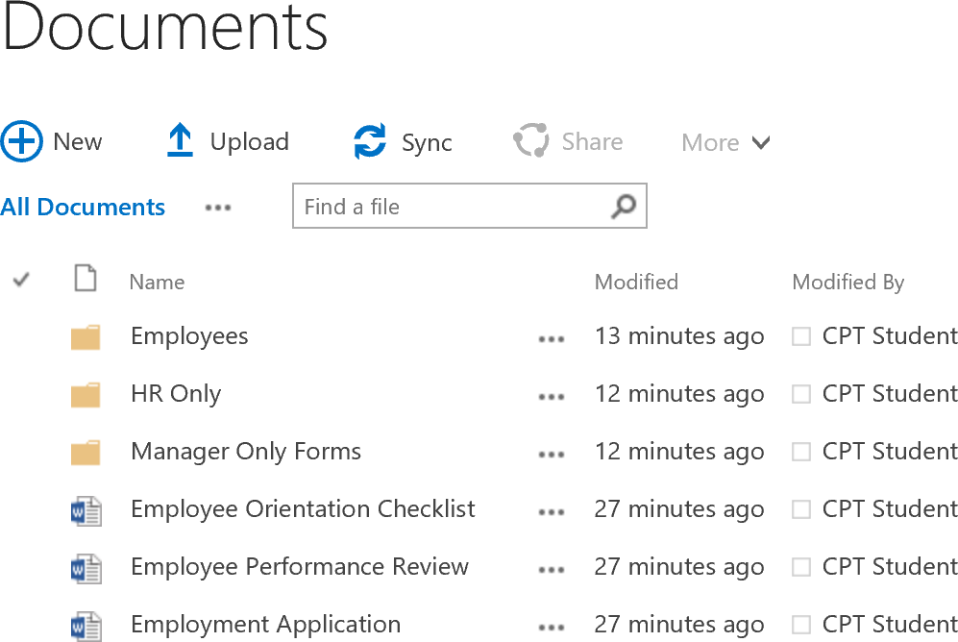

1. Move the Employee Orientation Checklist and the Employment Application into the HR Only folder:
   1. Click on the checkbox next to the **Employee Orientation Checklist** document and then hold down the shift key on the keyboard and select the **Employment Application** document. The selected items will now be highlighted blue as shown in the image below.

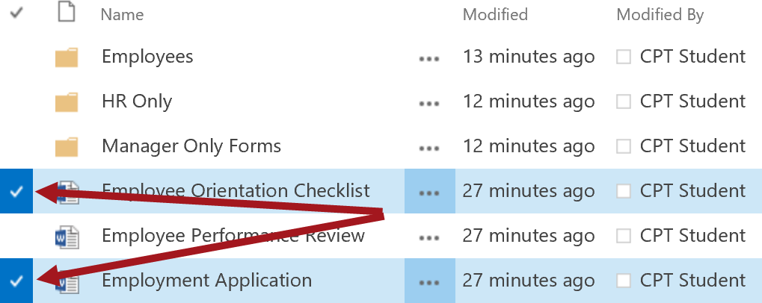

* 1. Click and hold the mouse down on the document icon for either one of the selected documents and drag the files to the **HR Only** folder and then release the mouse button. 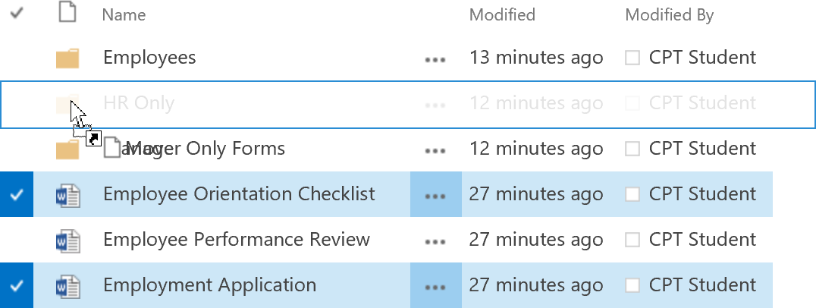
  2. The two files should now be moved into the HR Only folder.

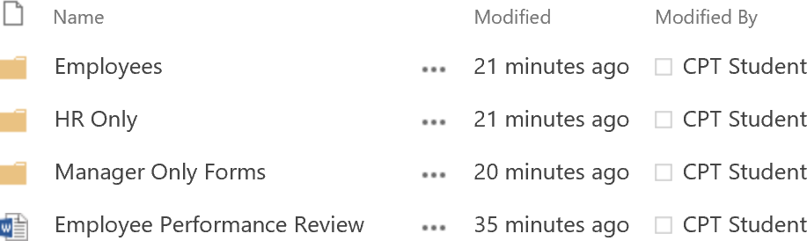

* 1. Click on the **HR Only** folder icon to open the HR Only folder to verify the documents have been moved into the folder.

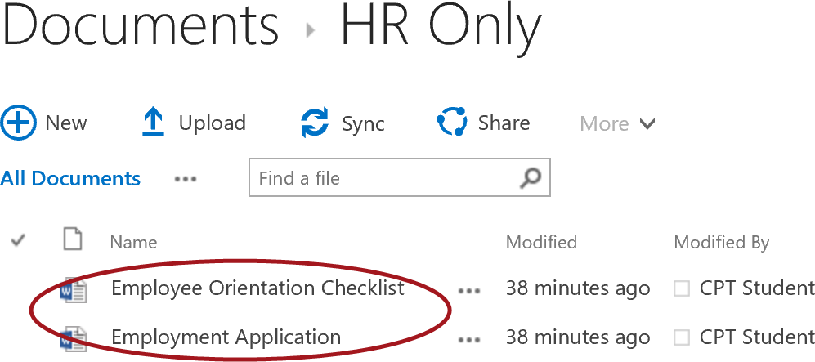

* 1. To navigate back up, click on the **Documents** link.

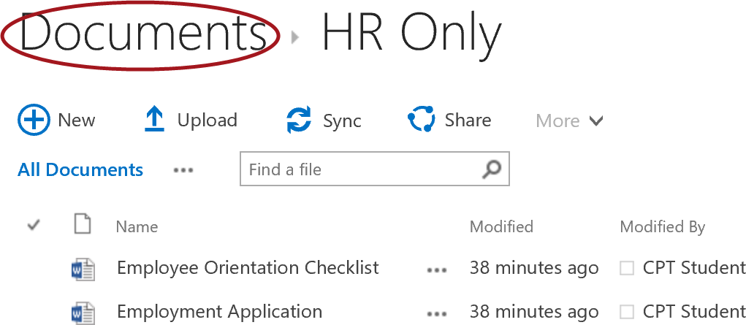

1. Use the same method of dragging and dropping to move the **Employee Performance Review** document into the **Manager Only Forms** folder.

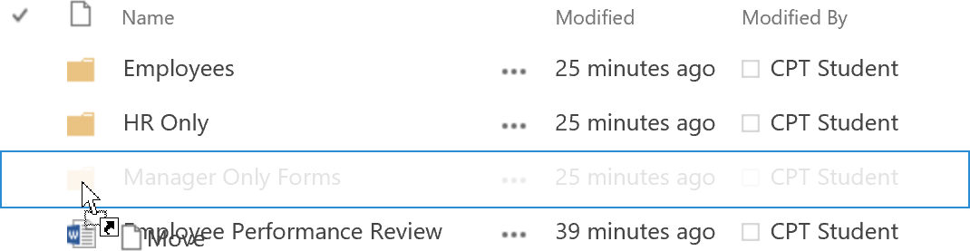

* 1. Click on the **Manager Only Forms** folder icon to open the Manager Only Forms folder to verify the documents have been moved into the folder.

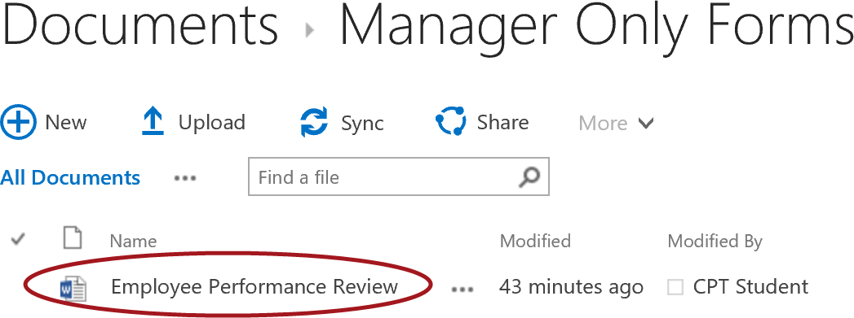

* 1. To navigate back up, click on the **Documents** link.

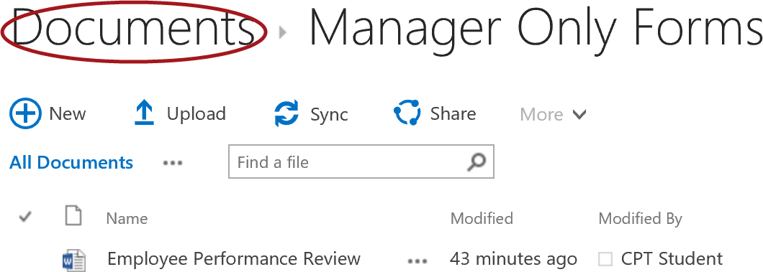

* 1. Your Documents library will now look similar to the image below.

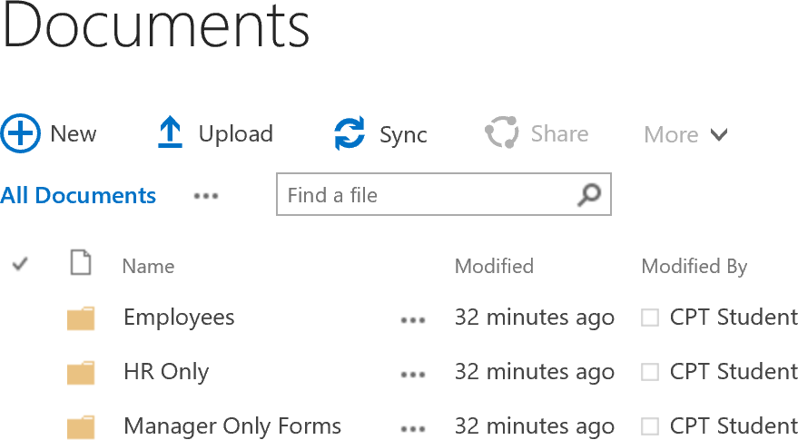

#### Delete Files and Folders

Deleting files and folders in SharePoint is easy to do. In this step, you will delete the Employee Orientation Checklist document and create/delete a new subfolder in the HR Only folder.

1. Delete the Employee Orientation Checklistdocument:
   1. Open the HR Only folder by clicking on the **HR Only** folder icon to open the folder.
   2. Select the **check mark** for the **Employee Orientation Checklist** document. Click on the **More** in the **Quick Command** **Bar** and choose **Delete**.

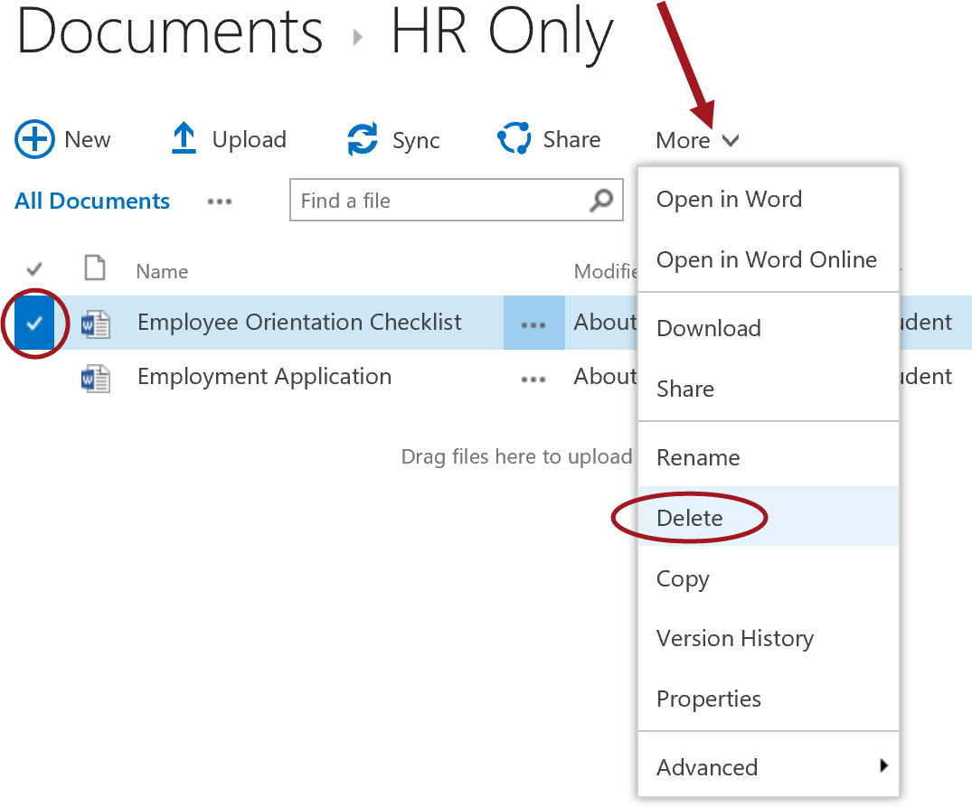

* 1. From the **send the item(s) to the site Recycle Bin** dialog, click **OK**.

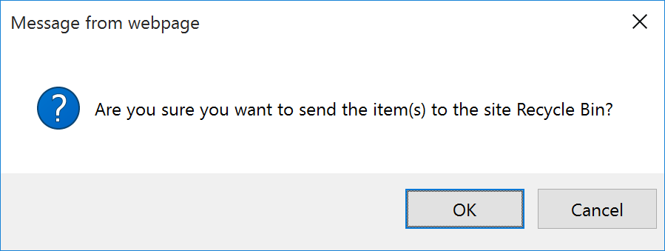

* 1. Notice the **Employee Orientation Checklist** document has been deleted.

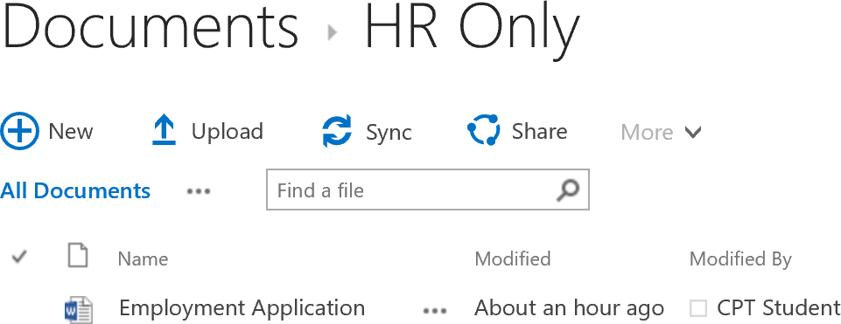

1. Create a new subfolder called **Awesome Docs** using the steps you learned in the Create New Folders section.

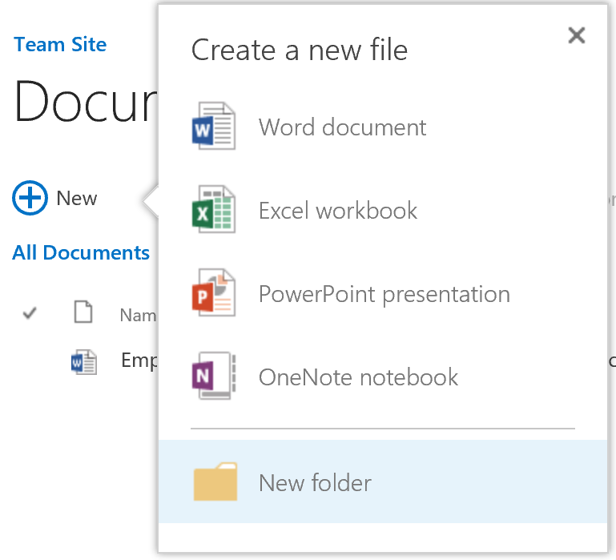

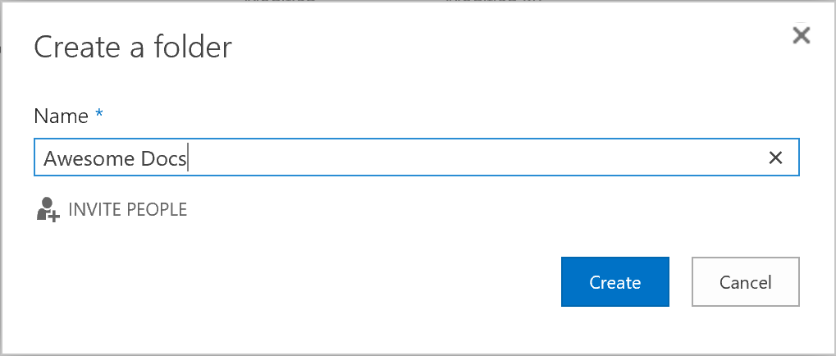

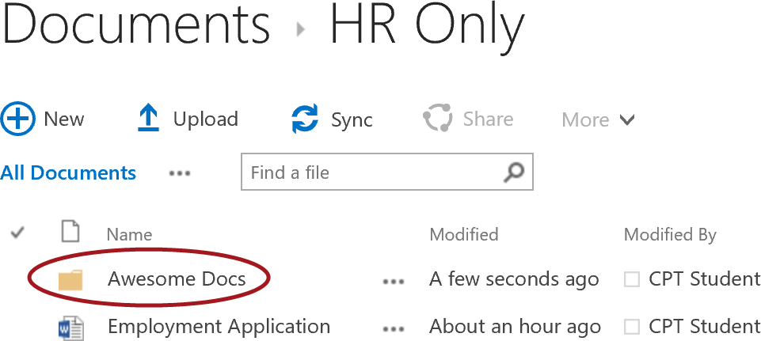

1. To delete the **Awesome** **Docs** subfolder:
   1. Select the **check mark** for the **Awesome Docs** folder. Click on the **More** in the **Quick Command** **Bar** and choose **Delete**.

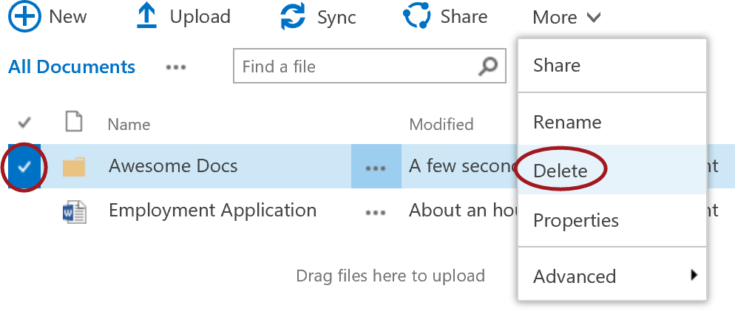

* 1. From the **send the item(s) to the site Recycle Bin** dialog, click **OK**.



* 1. Notice the **Awesome Docs** subfolder has been deleted.



#### Restore Deleted Files and Folders

Restoring files is easy in SharePoint because the deleted items get moved into the end user Recycle Bin. In this section, you will restore the file and subfolder that you deleted in the previous steps.

1. Restore the Awesome Docs folder and the Employee Orientation Checklist by following the steps below:
   1. Navigate to the Recycle Bin by clicking on the Recycle Bin link located in the Quick Launch.

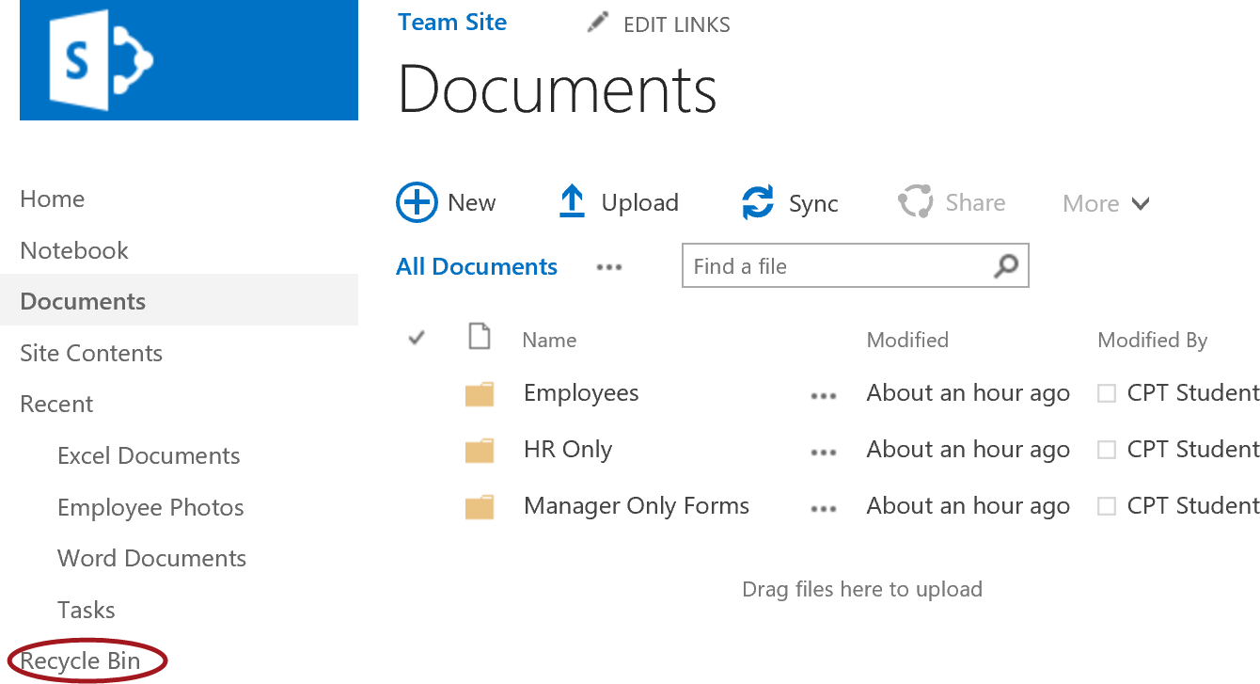

* 1. Select the check boxes for the **Awesome Docs** subfolder and the **Employee Orientation Checklist.docx** file then click on **Restore Selection**.

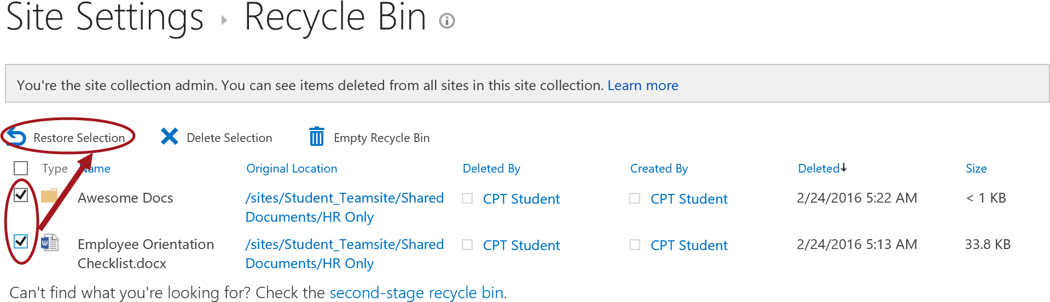

* + 1. When prompted **Are you sure you want to restore these items?** click **OK**.

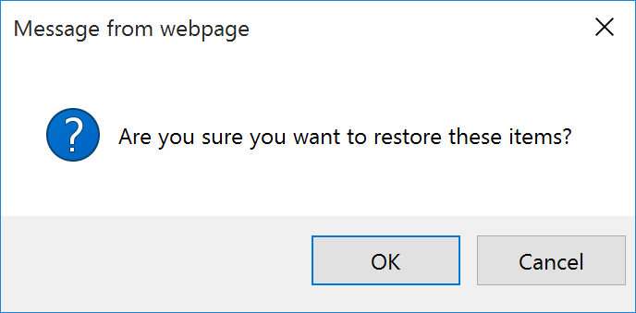

* 1. The files will be restored and will no longer show up in the Recycle Bin.

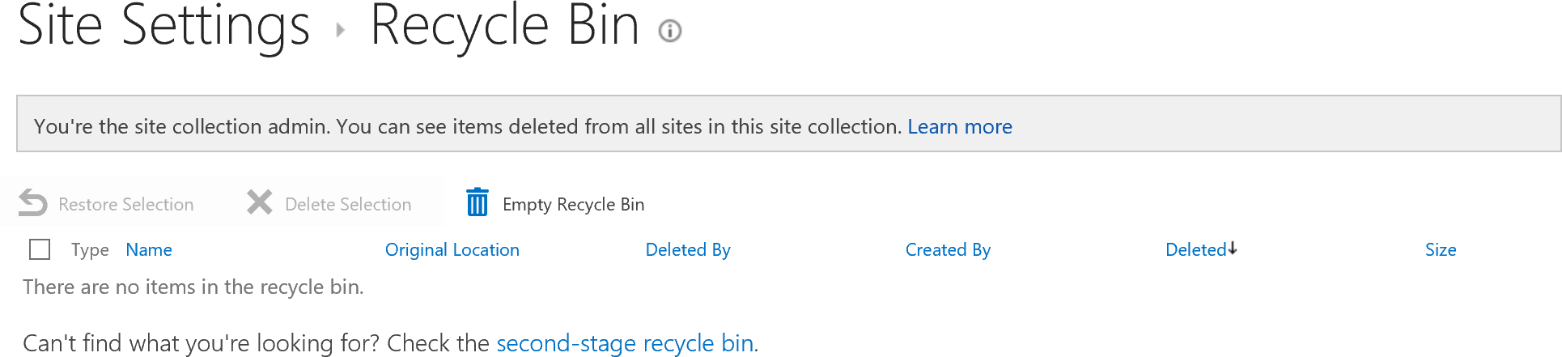

* 1. Navigate back to the **Documents** library and open the **HR Only** folder. Verify the **Awesome Docs** subfolder and the **Employee Orientation Checklist** have been restored.

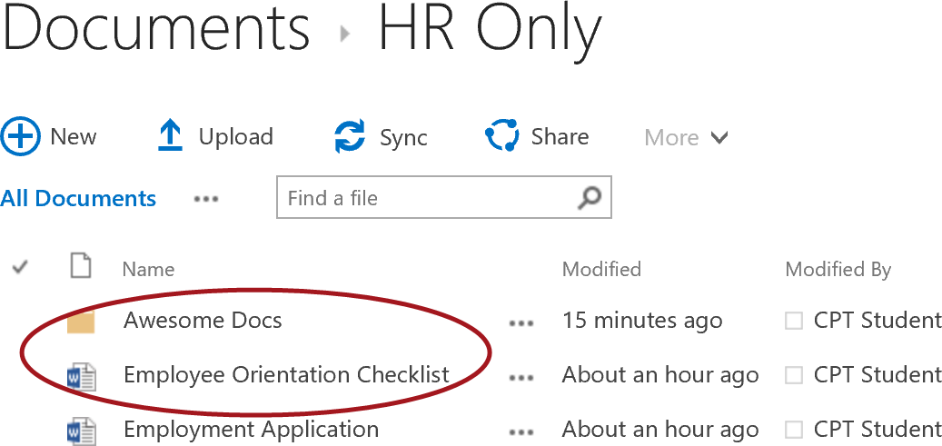

* 1. To navigate back up, click on the **Documents** link to take you back to the root of the document library.

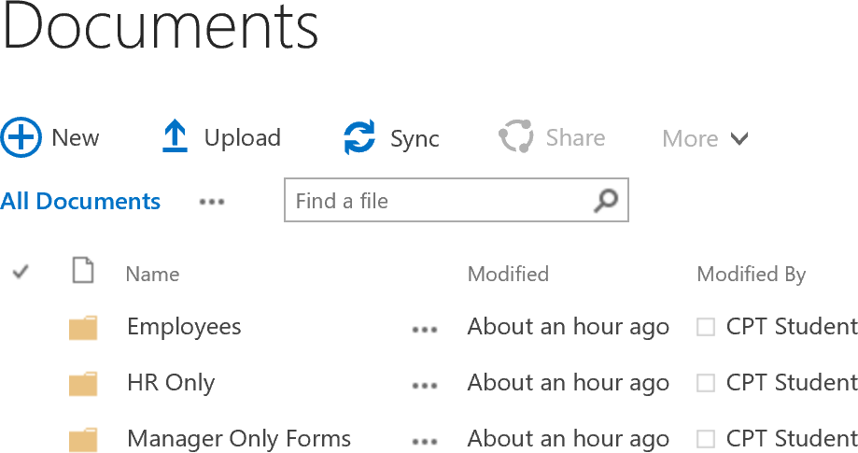

### Exercise 3: Customize Document Library

In the previous exercise, you created folders in the existing Documents library. Navigating through folders in a SharePoint document library provides the same experience as using a file share. Instead of using folders, it is recommended to use columns and custom views to provide a better experience for the user.

In this exercise, you will customize the document library by adding a **Category** choice column, set the category for each document, create a new view that groups the documents by Category, and turn on the option in the view to Show all items without folders.

#### Create Column

In this step you will create a choice column called **Category** with **Employees**, **HR Only**, and **Manager Only Forms** as the available options. These choices are the same names as the folders you created in the Documents library.

1. Navigate to the Library Settings for the Documents library:
   1. Click on the **LIBRARY** tab and then click on the **Library Settings** ribbon button.

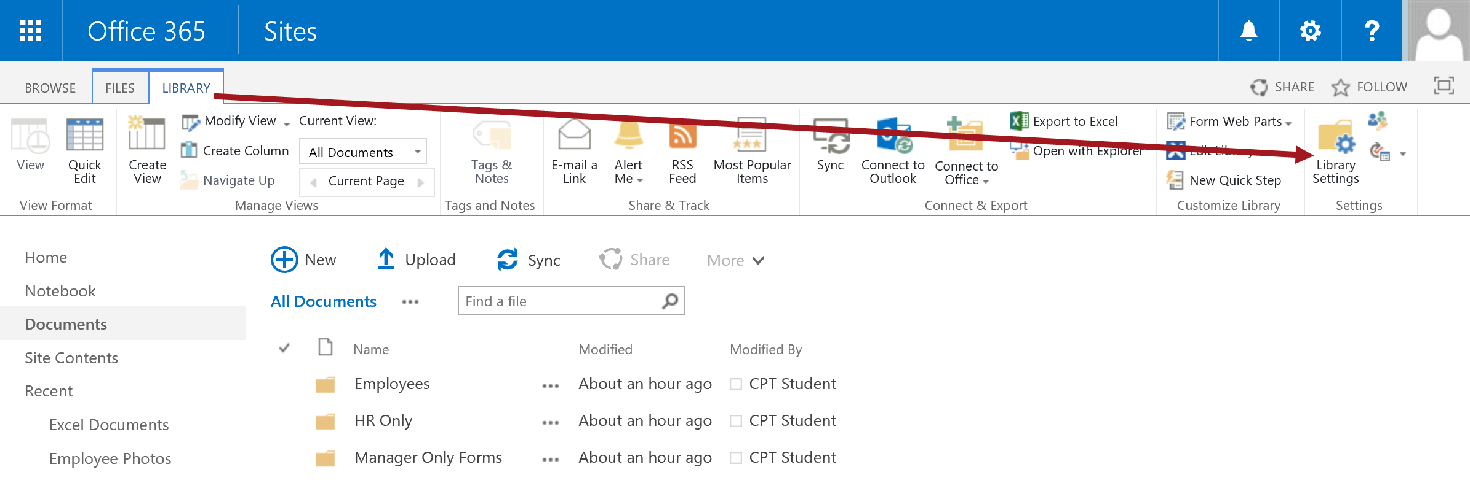

1. Create the new Category column following the steps below:
   1. In the **Columns** section, click the **Create** **column** link.

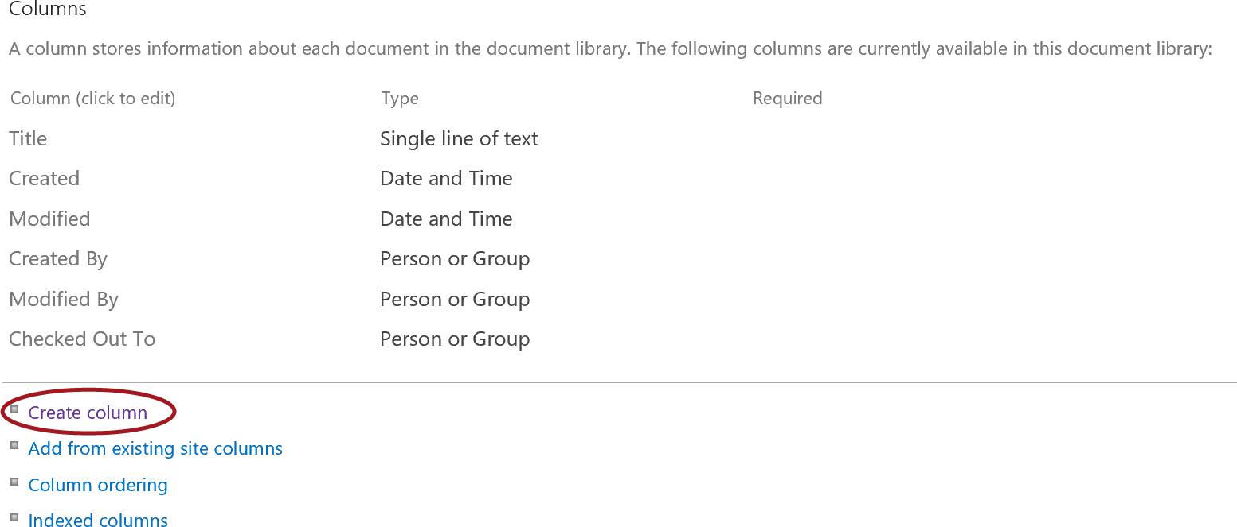

* 1. In the **Column** **name** text box, type **Category** then select the **Choice (menu to choose from)** radio button.

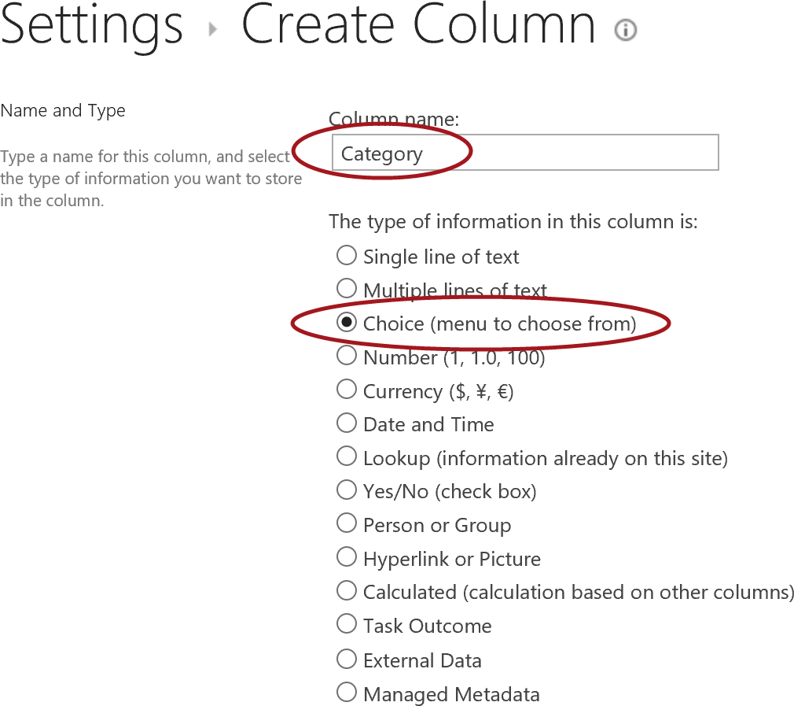

* 1. In the **Type each choice on a separate line** multi-line text box, type **Employees** (then hit enter), type **HR Only** (then hit enter), and type **Manager Only Forms** (then hit enter).

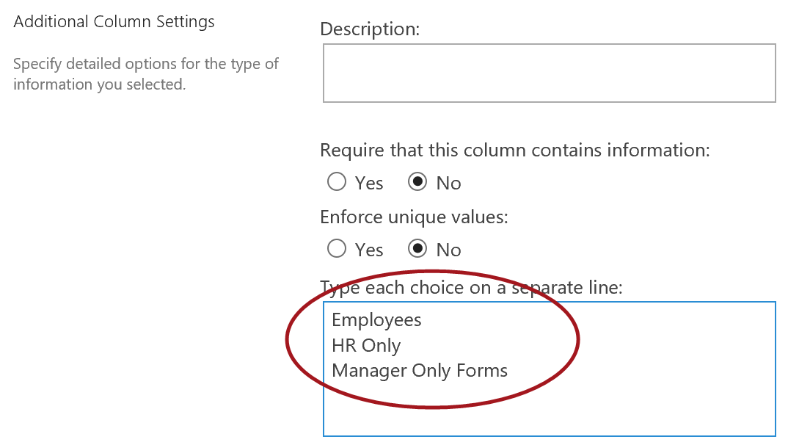

* 1. Ensure the **Drop-Down Menu** radio button is selected and **Allow ‘Fill-in’ choices** is set to **No**.

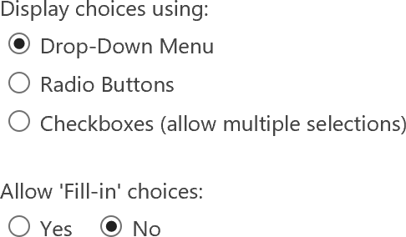

* 1. In the **Default** **value** with the **Choice** option selected, delete **Employees** from the text box. Ensure **Add to default view** is selected and then click **OK**.

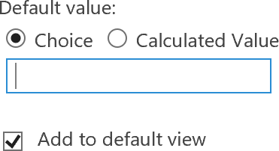

* 1. Notice the column has now been added and shows up in the list of columns.

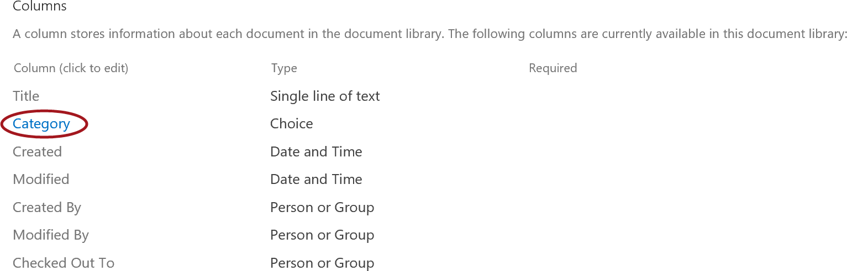

* 1. To go back to the library, click on the **Documents** link located at the top of the settings page.

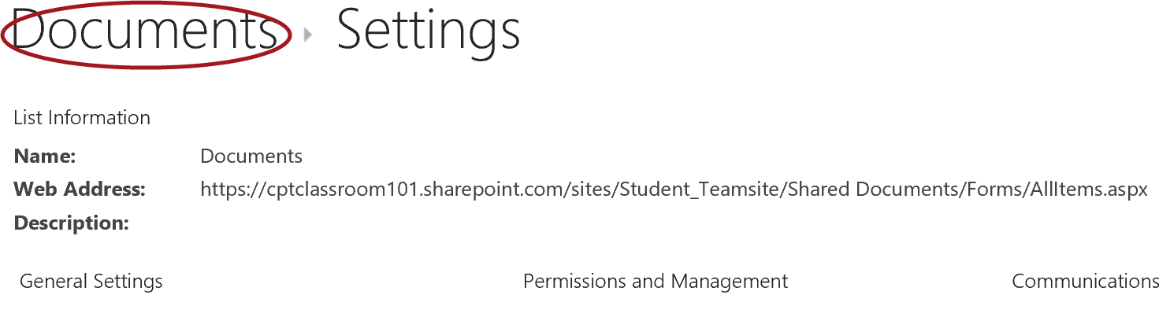

* 1. The Category column has been added to the default view.

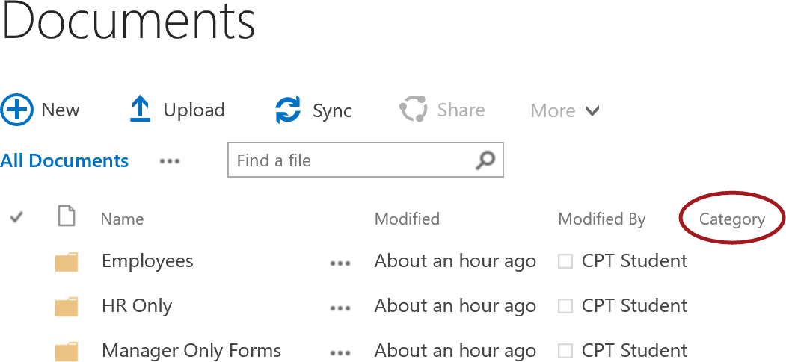

#### Create a New View

To make it easier to view the documents, you are going to create a new view, set the group by to use the Category column, and hide the folders.

1. To create the new view:
   1. Click on the **ellipsis (…)** next to the All Documents view, then choose **Create View**.

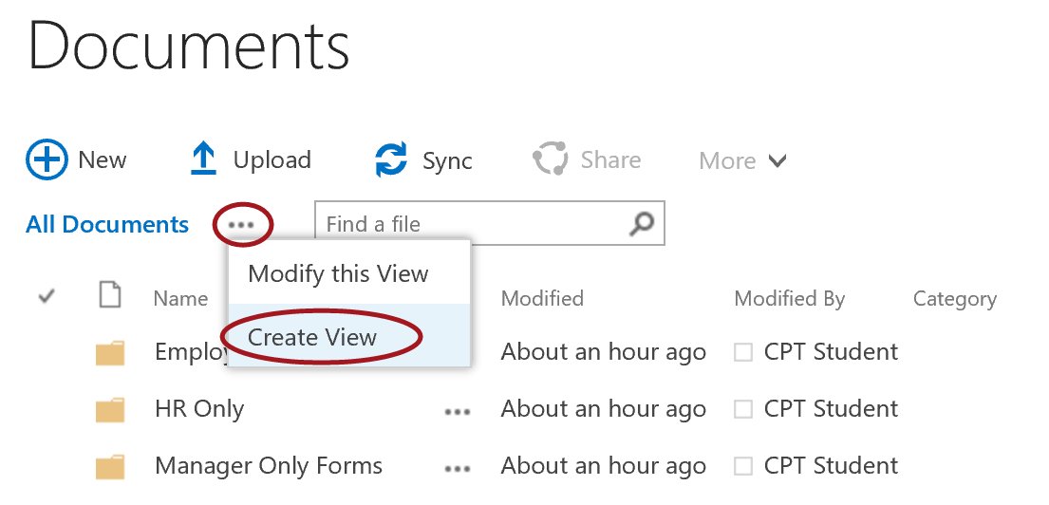

* 1. Click on **All Documents** for the View Type.

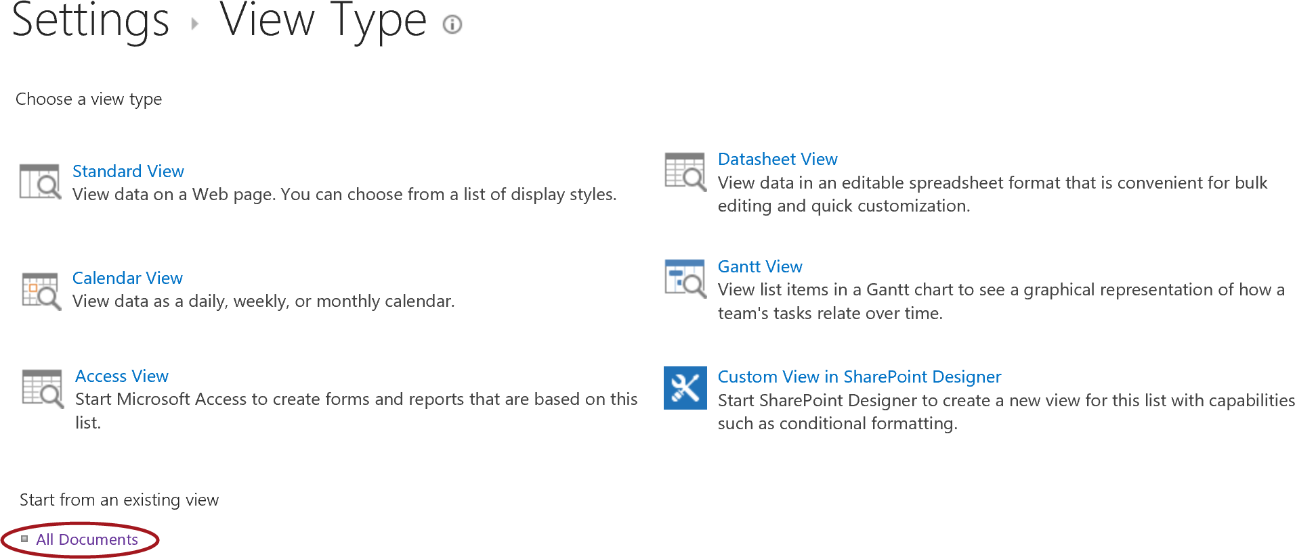

* 1. For the View Name, type **Category View**. Leave the **Create a Public View** option selected and uncheck the **Category** column from the Columns display as shown in the image below.

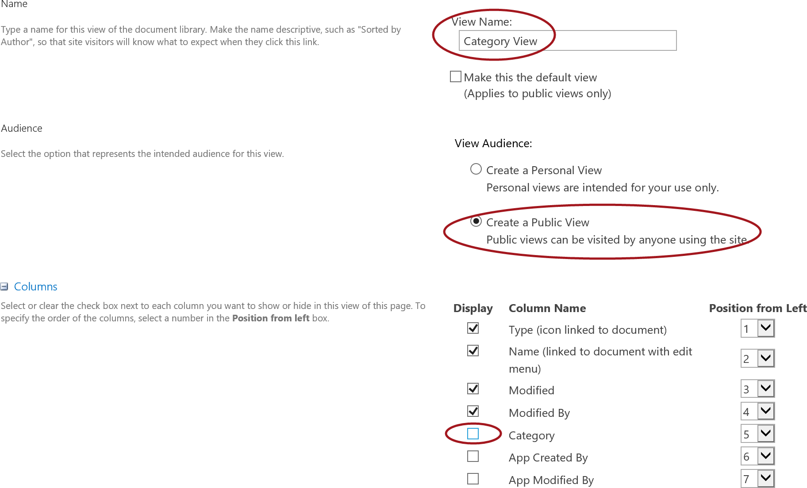

* 1. Scroll down and click on the **+** symbol next the **Group By** section.

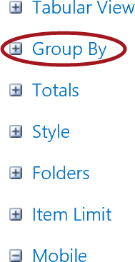

* 1. From the **First group by the column** drop-down list, select **Category**. Ensure the **Show groups in ascending order** is selected. Leave **Then group by the column** set to **None**. In the **By default, show groupings property**, select **Expanded**.

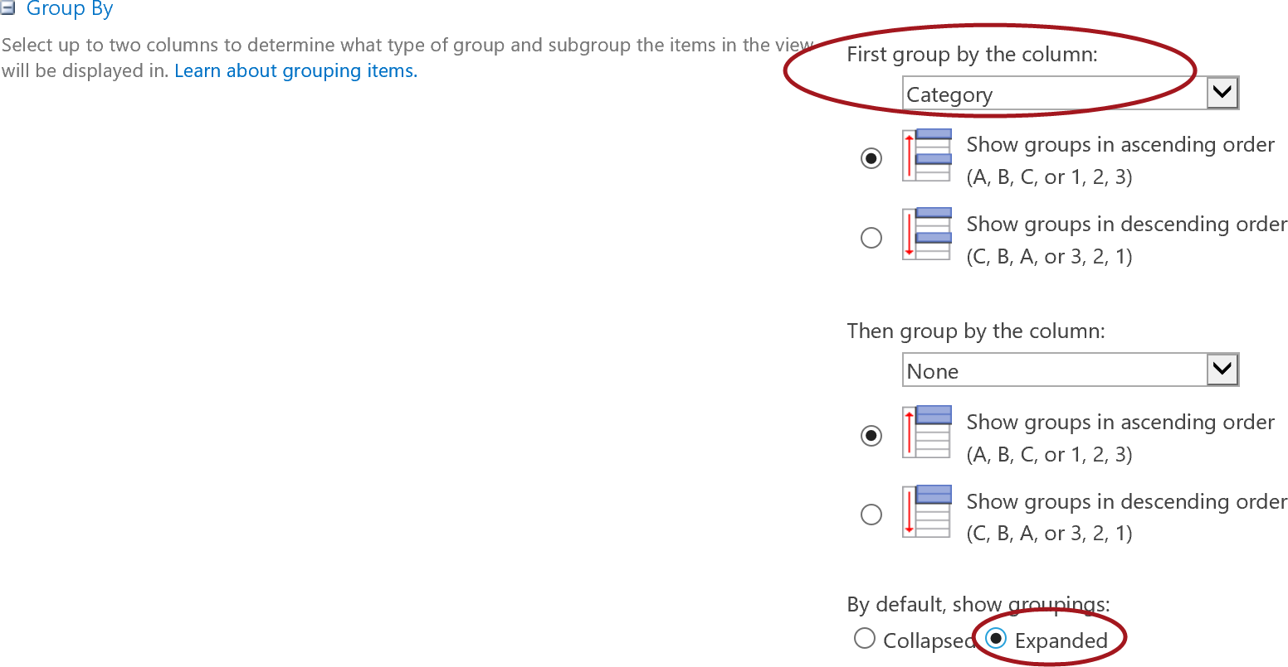

* 1. Expand the **Folders** section and set the **Folders for Flat** option to **Show all items without folders**. Then scroll down to the bottom and click **OK**.

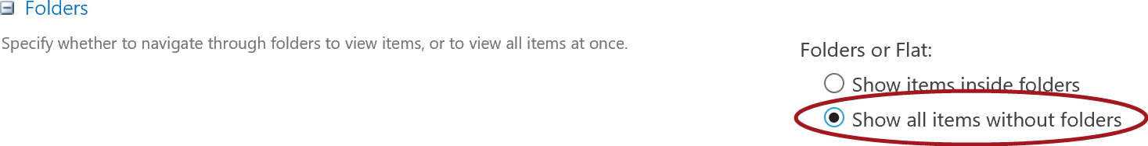

* 1. Scroll to the top or bottom of the page and then click **OK**.
  2. Notice the documents are grouped by Category and no folders are showing but the documents are displayed.

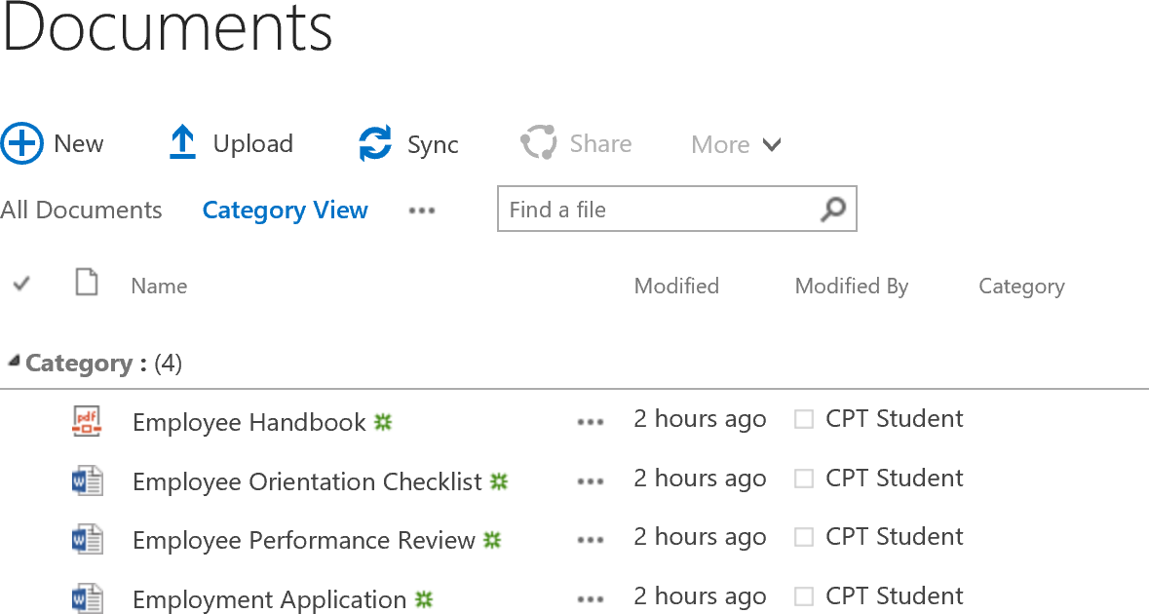

#### Assign Category to Each File

In this section, you will assign a Category to each of the documents in the library.

1. Set the Category for the Employee Handbook document to Employees:
   1. Select the **check mark** for the **Employee Handbook** document. Click on **More** in the **Quick Command** **Bar** and choose **Properties**.

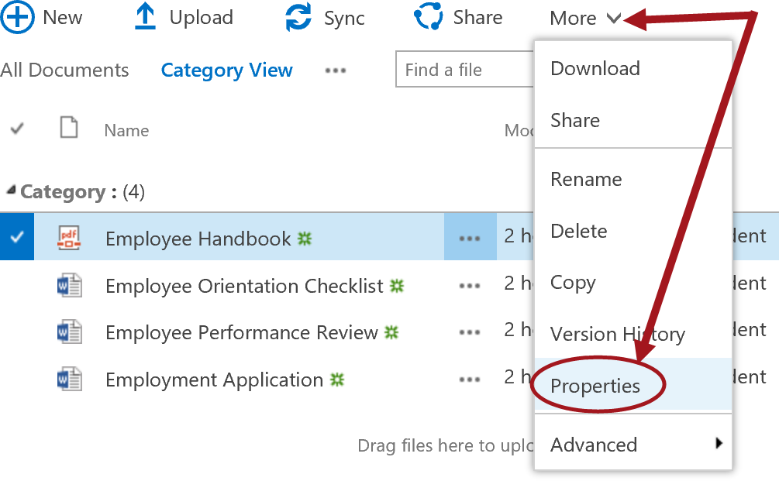

* 1. Set the **Category** to **Employees**. Click **Save**.

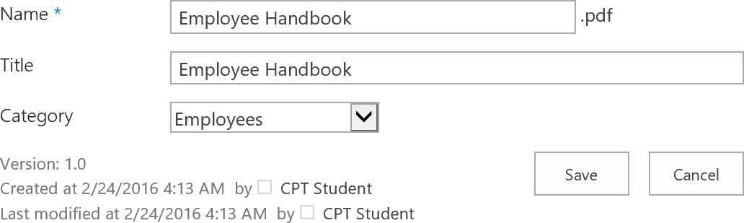

* 1. Notice the Employee Handbook is now grouped by the Employees Category.

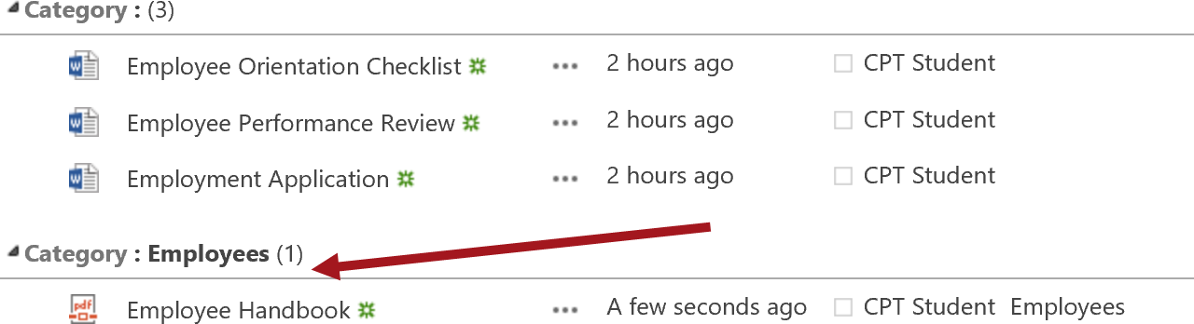

1. Repeat the steps and assign the following:
   1. Set **Employee Orientation Checklist** and **Employee Application** to **HR Only**.
   2. Set **Employee Performance Review** to **Manager Only Forms**.
2. When complete, your documents should now be grouped similar to the image below.

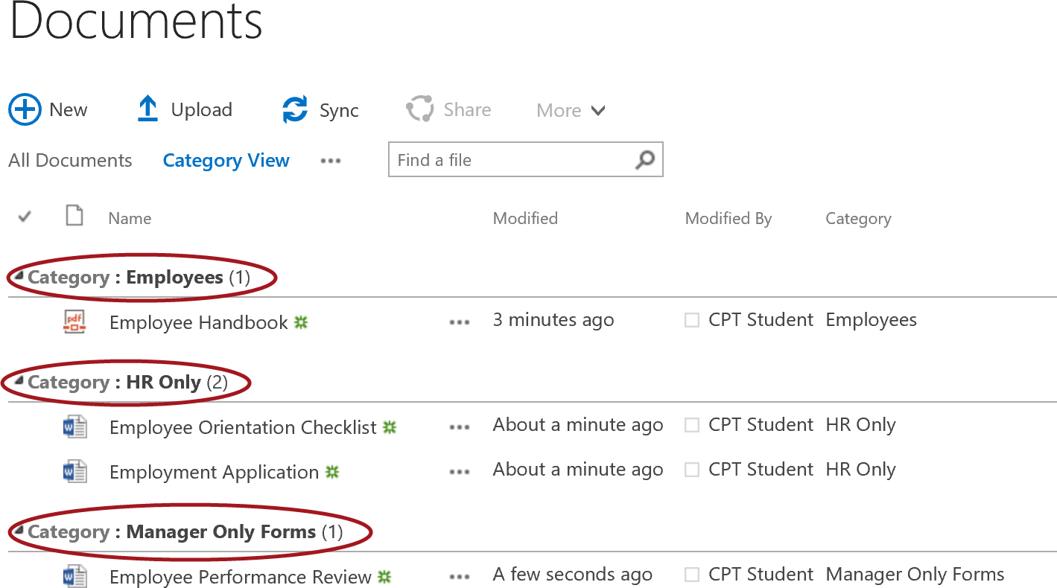

### Exercise 4: Configure Versioning for Co-Authoring

SharePoint versioning helps protect documents and prevent data loss by allowing authors to roll back to a previous document version when the current version contains unwanted changes.

Do not enable minor versioning in document libraries that contain OneNote notebooks. Minor versioning can result in synchronization errors that prevent edits from being saved.

When multiple authors work on the same document, edits are retained on the server as document versions. To limit server storage usage, you can limit the number of retained versions. If you enable major versioning in a document library that contains OneNote notebooks, we recommend that you specify the maximum number of versions so you can use disk space more efficiently.

#### Enable/Modify Versioning

1. To enable or modify the versioning settings following the steps below:
   1. From the **LIBRARY** tab, in the Settings group click on the **Library** **Settings** ribbon button.
   2. In **General Settings**, click on **Versioning settings**.

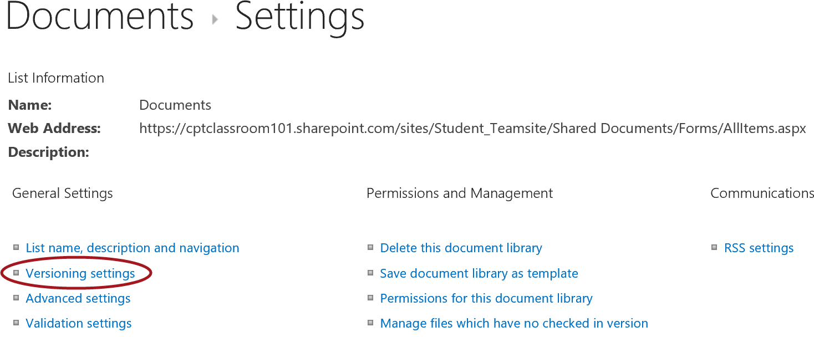

* 1. In **Document Version History**, notice the **Create major versions** is selected and the revision limit is set to **500**. These are the default settings when a document library.

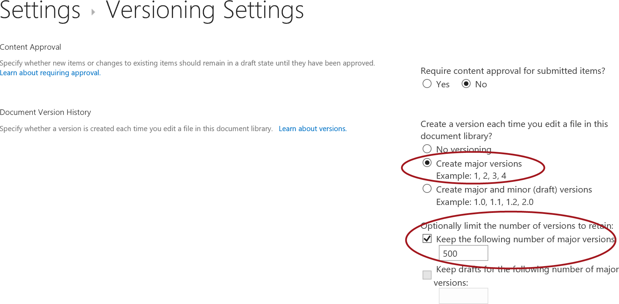

**Why enable versioning?** When versioning is enabled, you can track and manage document and metadata changes. You can look at earlier versions of documents and recover them if necessary when versioning is enabled. Some organizations require retaining multiple versions of items for legal reasons and audit purposes. You may also want to track both major and minor versions of a document. A major version can signal a document is ready for review by a wide audience, whereas a minor (draft) version is a work-in-progress and not yet ready for wide circulation.

Content Approval – Turn this on only if you want to require content approval for documents submitted in this library.

#### Configure Require Check Out

When a document is checked out of a document library, the document is locked. This makes it unavailable for co-authoring. Therefore, the Require Check Out setting should not be enabled in document libraries that are used for co-authoring. By default, for SharePoint Online document libraries, this setting is not enabled.

1. To enable Require Check Out
   1. Browse to the **Word Documents** library or to the document library you want to configure.
   2. From the **LIBRARY** tab, in the Settings group click on the **Library** **Settings** ribbon button.
   3. In **General Settings**, click on **Versioning settings**.
   4. In **Require Check Out**, select **Yes**.

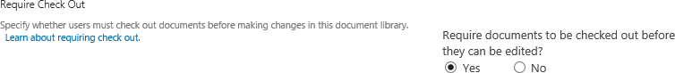

1. To disable Require Check Out
   1. Browse to the **Word Documents** library or to the document library you want to configure.
   2. From the **LIBRARY** tab, in the Settings group click on the **Library** **Settings** ribbon button.
   3. In **General Settings**, click on **Versioning settings**.
   4. In **Require Check Out**, select **No**.

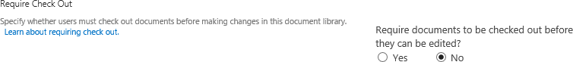

#### Check Out/Check In Document

Checking documents in and out allows you to obtain exclusive write access to a document, which eliminates the need to merge changes from multiple authors. When you check out a document, you are the only one who can save the changes to the document until you check the file back in. Follow the steps below to check out, make changes, save, and then check in a document.

1. To Require Check Out, scroll down to the bottom of Versioning Settings page you are currently in and change the **Require documents to be checked out before they can be edited?** to **Yes**.



1. To Check Out a document, click on the **ellipsis (…)** for the **Employee Orientation Checklist** document then click on the **ellipsis (…)** in the document dialog. Choose **Advanced** then select **Check Out**.

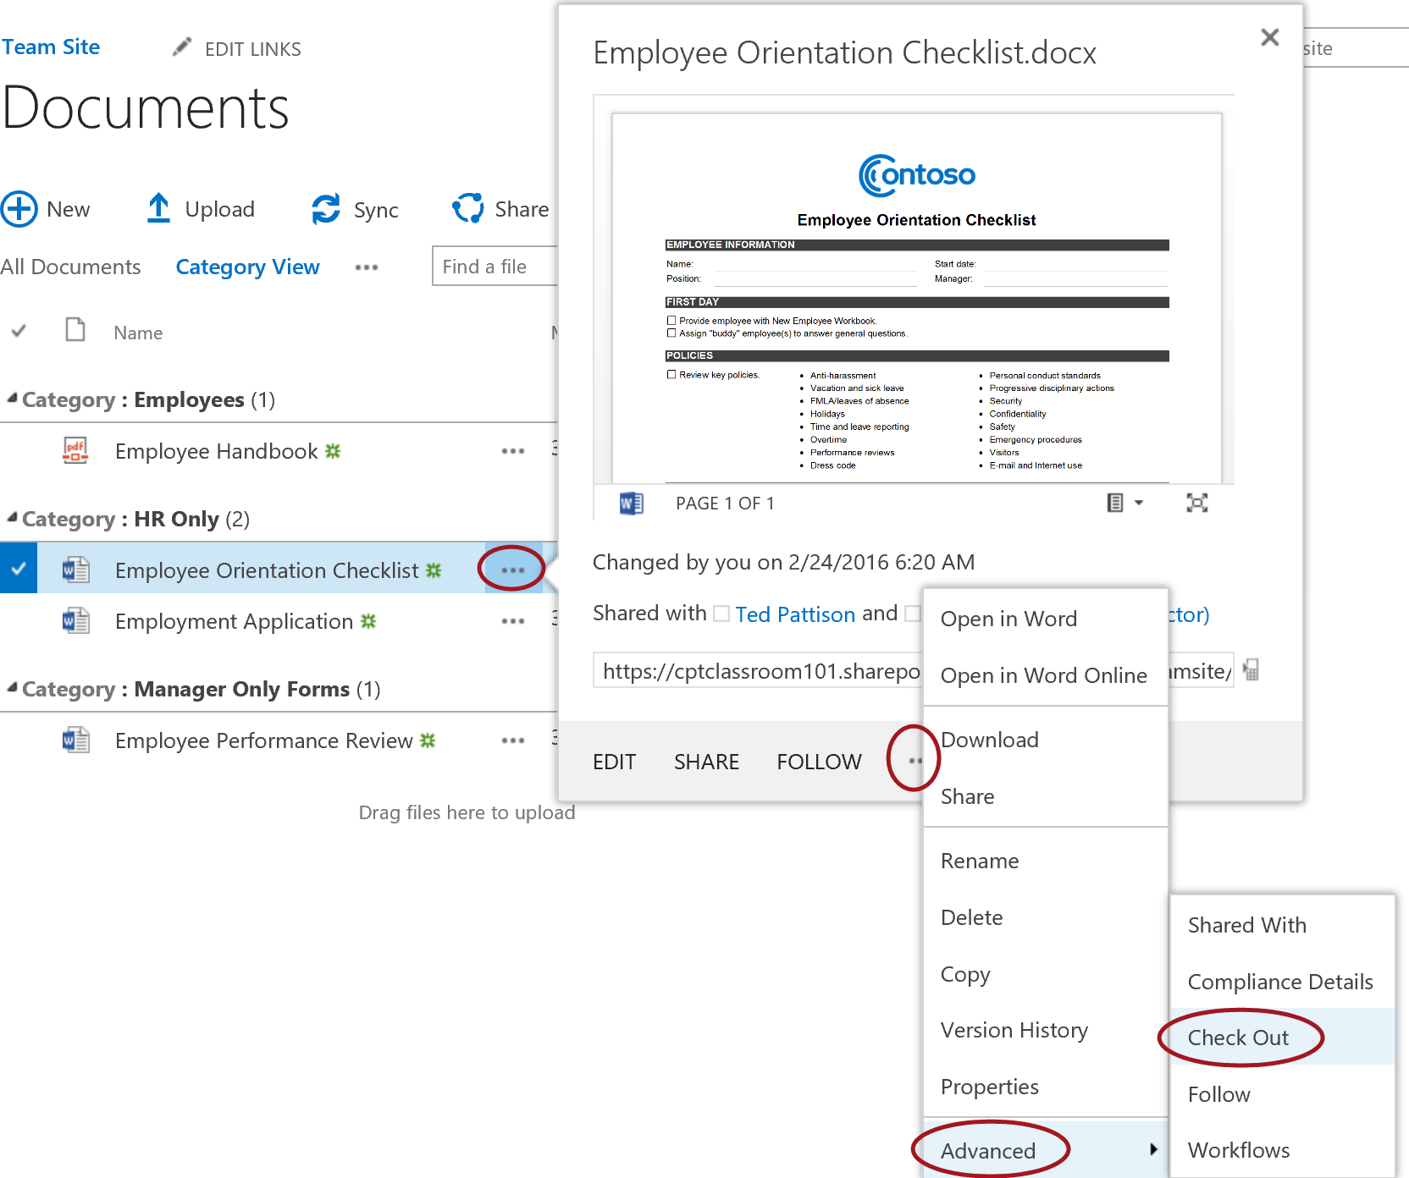

1. Notice the document icon now has an arrow. This arrow indicates the file is checked out.

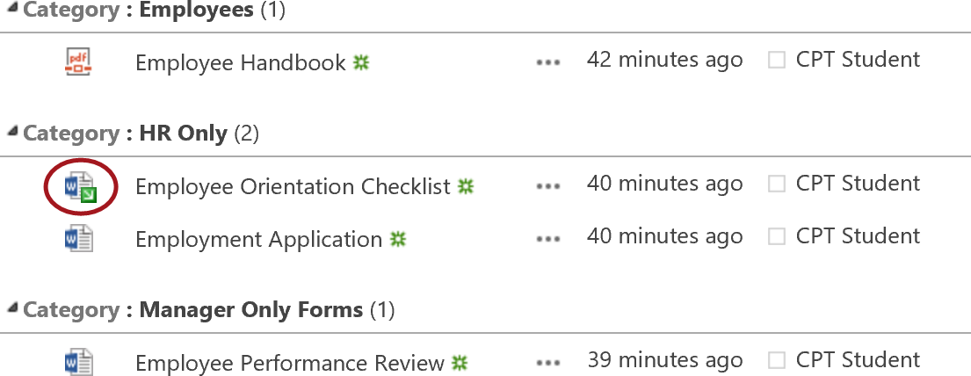

1. Click on the name **Employee Orientation Checklist** to open the file. The document will open in Word Online. You can edit the document either through the Word client or Word Online by selecting the **Edit Document** dropdown to get to the list of edit options.

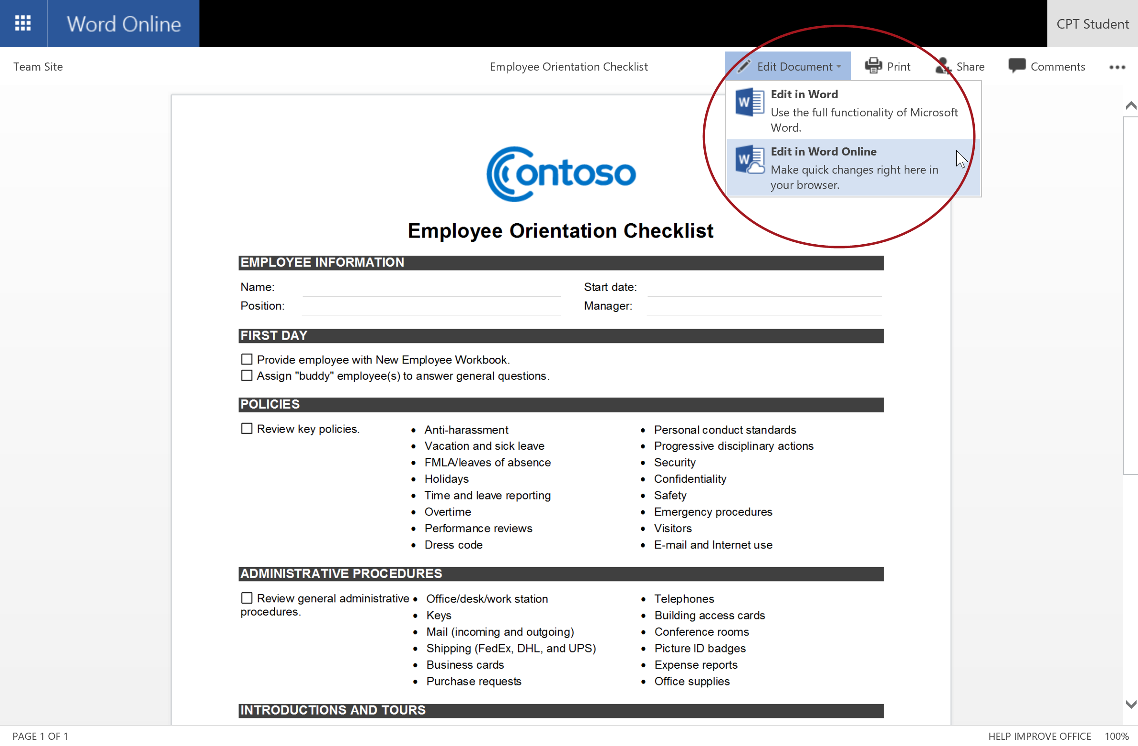

1. Choose **Edit in Word**. Make change to the file and then click the Save icon.

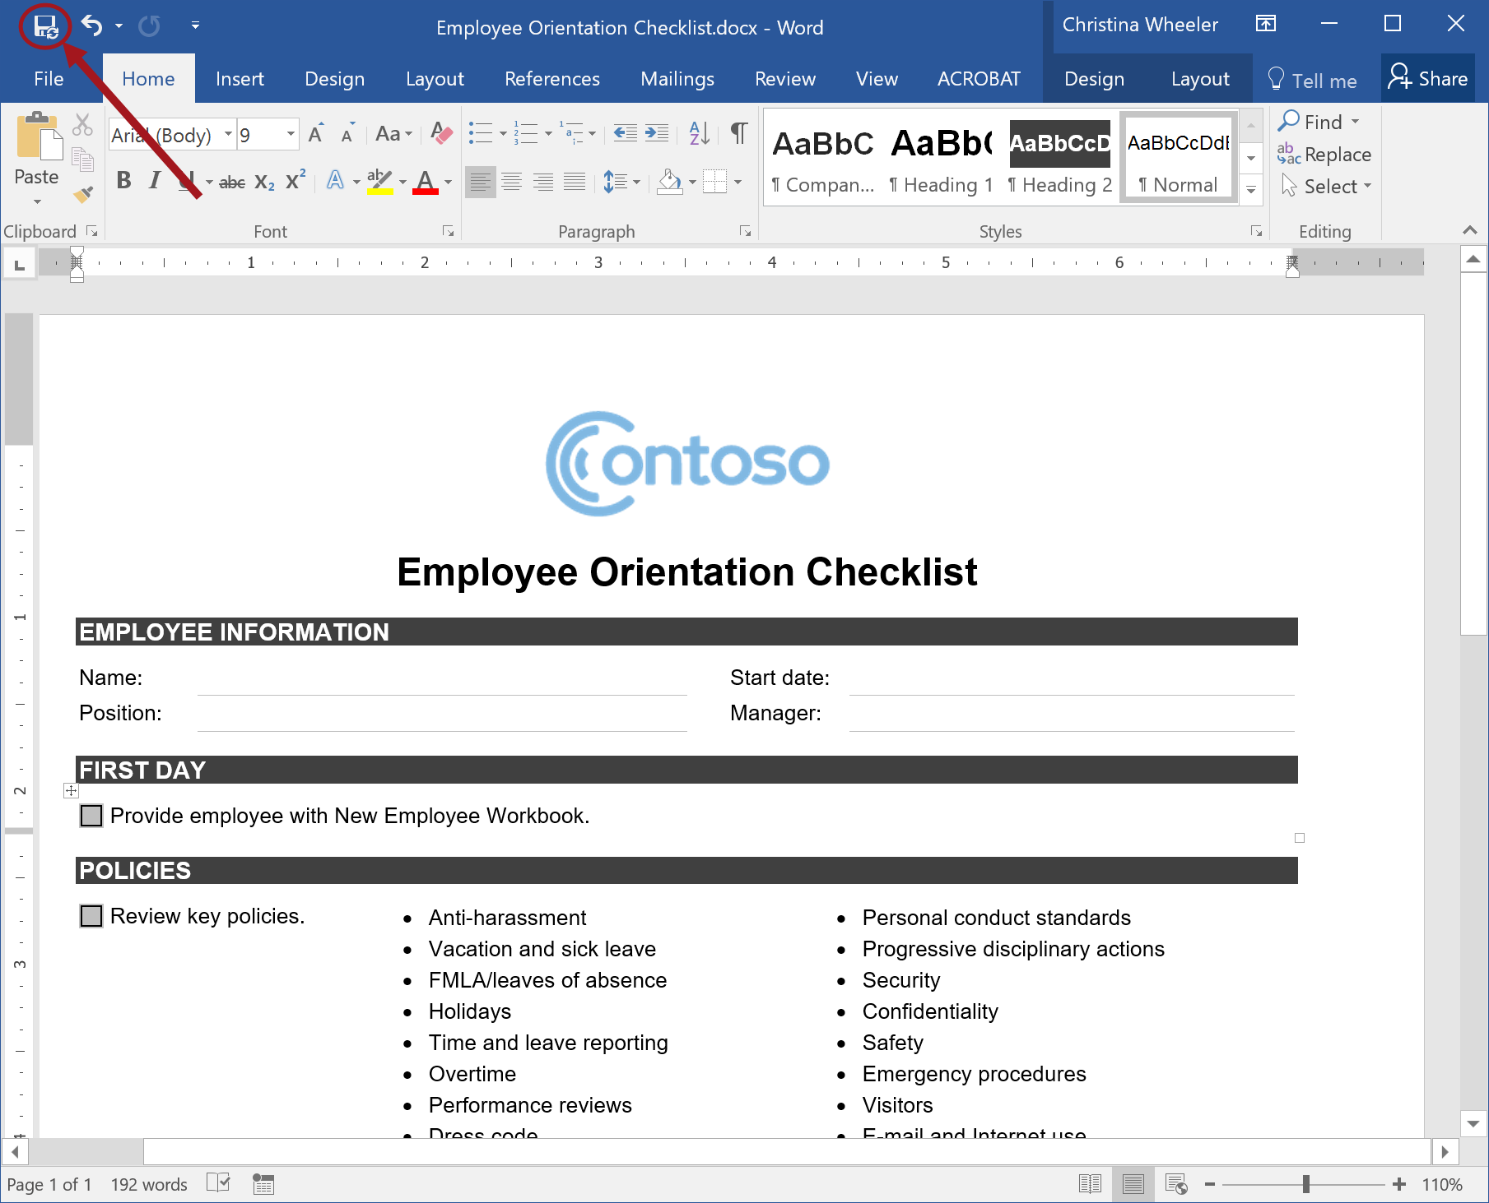

**Note:** In some cases, you may want to leave the file checked out while you continue to make updates the next day. You can save the file and keep it checked out and then check in the file when you are ready to publish the changes. If you close the file, you will be prompted with a dialog confirming if you want to check in the file. If you click No your changes will still be saved but the file will remain checked out. All users will only have read access to the file while it is still checked out and they will only see the latest published version.

1. To **Check In** or **Discard Check Out** through Word, select the **File** tab to get to the Info panel to access the Checked Out Document options.

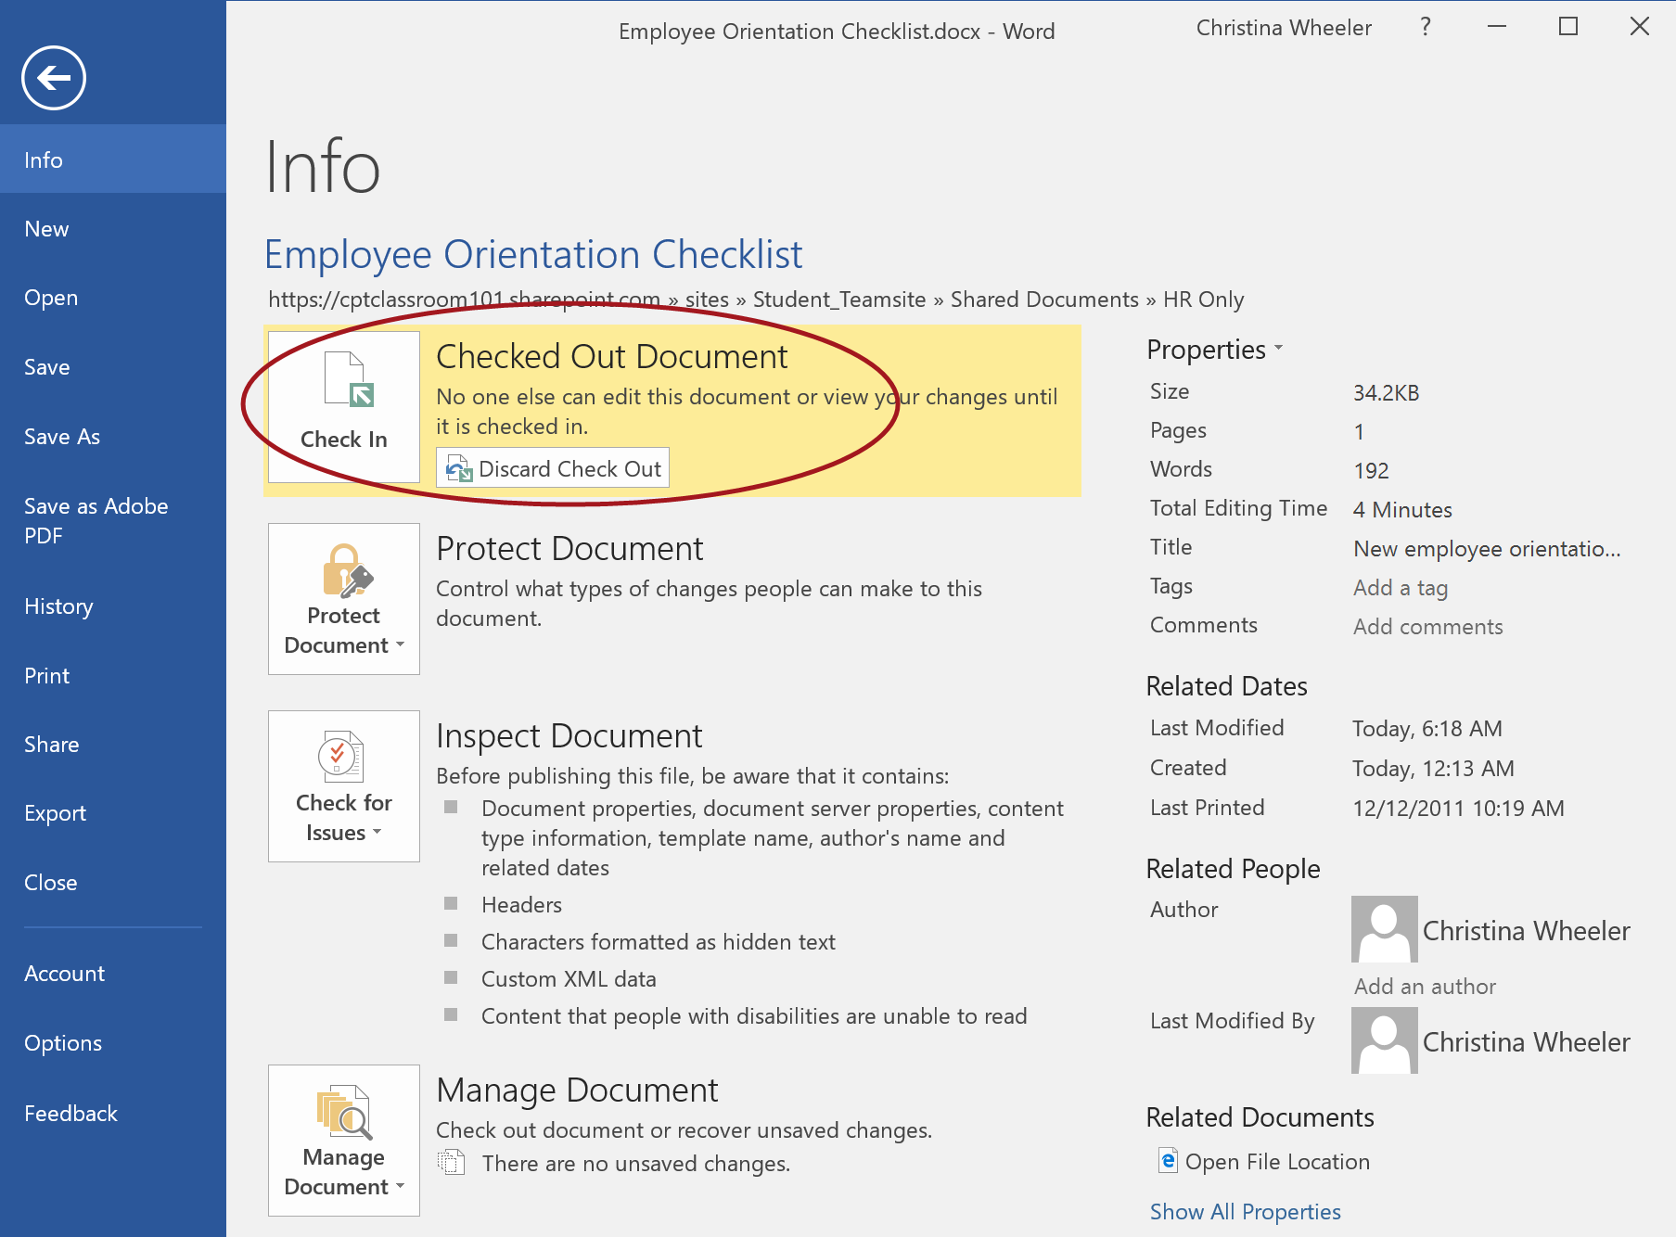

* 1. To Check In the document, click the Check In option. From the **Check in** dialog, enter any desired **Comments** (optional) and then click **OK**.

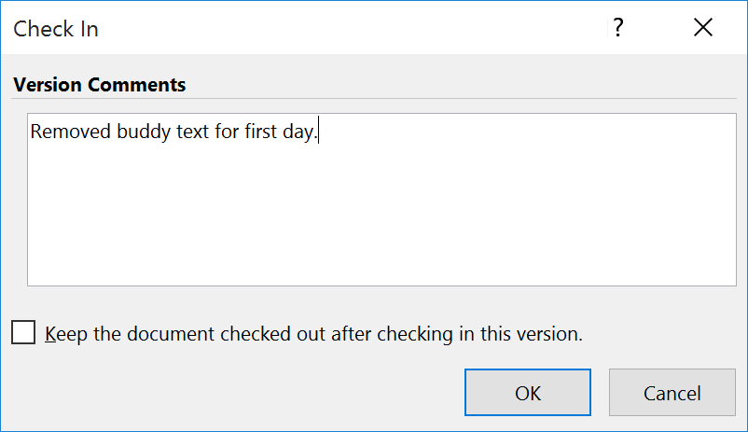

**Note:** If you want to retain your checkout but publish the latest changes so the users can see the updates, set **Retain your check out after checking in** to **Yes**.

1. Word will keep the document open and display the following messages because the file is checked in.



1. Close the file in **Word**.
2. Go back to the browser and click on **Team Site** in Word Online to navigate back to the document library.

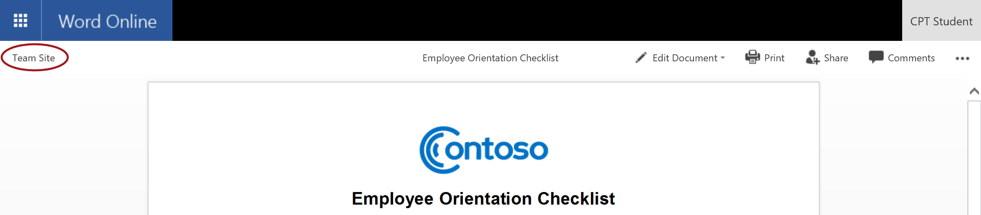

1. Notice the document icon no longer shows an arrow, indicating that the file is no longer checked out.

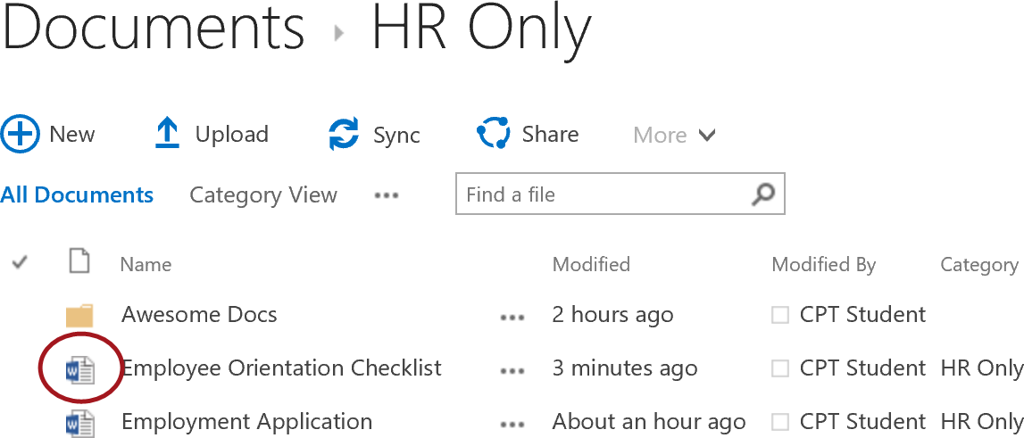

### Exercise 5: Update Document Library Templates

In this exercise you will change the document library template for the document library you created in exercise 1. You will create a new document library that will default to Excel and change the default template for the library.

#### Update the Word Document Library Template

1. Navigate to the **Word Documents** library.
2. From the **LIBRARY** tab, click **Library** **Settings** ribbon button located in the **Settings** group.
3. Under the **General** **Settings** section, click on the **Advanced** **settings** link.

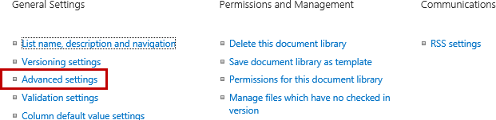

1. In the **Document** **Template** section under the **Template** **URL** property, click on **(Edit Template)**.

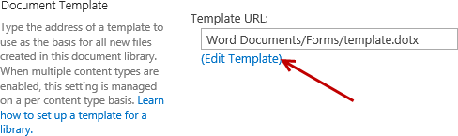

1. From the client computer, open **Windows Explorer** and navigate to **C:/Student/Documents/Lab**.
2. Double-click on the **Time Sheet.docx** file to open the file in **Word**.

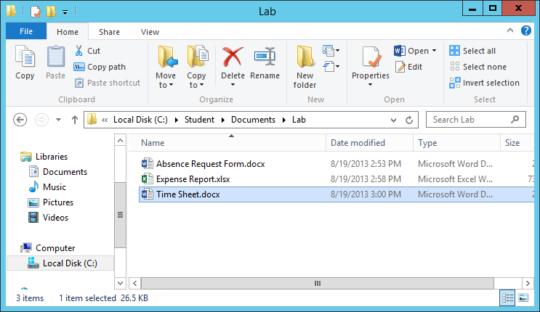

1. Copy content from the **Time Sheet.dotx** file and paste into the **template.dotx** file:
   1. Select all content (**Ctrl +A**).
   2. Copy the content (**Ctrl + C**).
   3. Close the **Time Sheet.docx** file.
   4. Now paste (**Ctrl + V**) the content into the template.dotx file that is open in Word.
2. Save the **template.dotx** file and then close Word.
3. From the browser, navigate back to the root of the **Word Documents** library.
4. From the **Files** tab of the **Word Documents** library, expand the **New Document** **drop-down list and** click **New Document**.

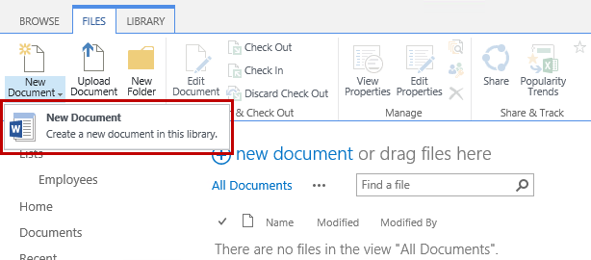

1. Word will open using the updated template.dotx file and the Document Properties panel should display on top which includes the Title and Category fields.

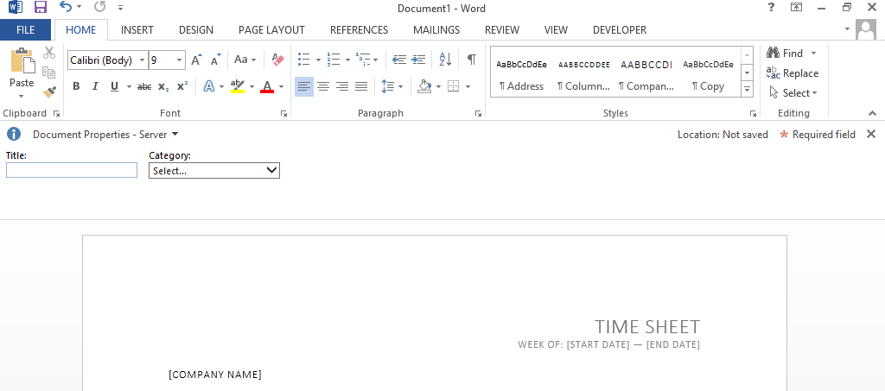

1. From the **Document Properties** panel, set the **Title** and **Category** to a desired value.
2. Update the contents of the Time Sheet file and once complete hit **save**.
3. From the **Save As** panel, click on **Word Documents** located under the **Current Folder** section.

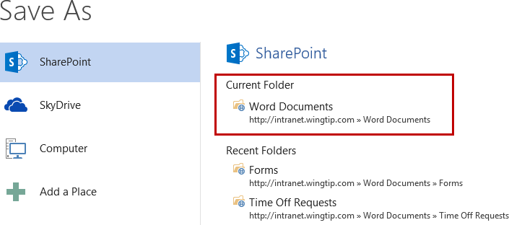

1. Update the **File name** and then click **Save**.

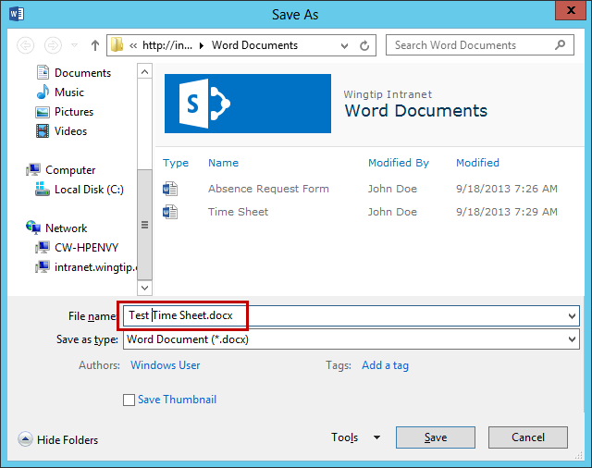

1. Close Word.
2. From the browser, navigate back to the **Word Documents** library and notice your new file has been saved.

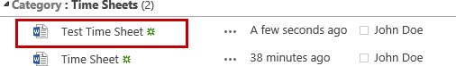

#### Update the Excel Documents Library Template

1. Navigate to the **Excel Documents** library.
2. From the **LIBRARY** tab, click **Library** **Settings** ribbon button located in the **Settings** group.
3. Under the **General** **Settings** section, click on the **Advanced** **settings** link.



1. In the **Document** **Template** section under the **Template** **URL** property, click on **(Edit Template)**.

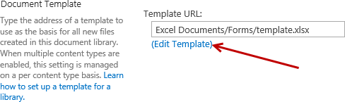

1. From the client computer, open **Windows Explorer** and navigate to **C:/Student/Documents/Lab**.
2. Double-click on the **Expense Report.xlsx** file to open the file in **Excel**.

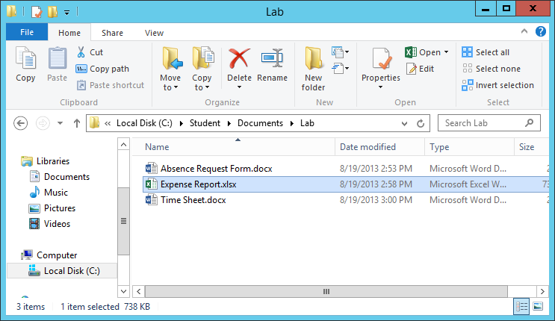

1. Copy content from the **Expense Report.xlsx** file and paste into the **template.xlsx** file:
   1. Right-click on the **Expense Report sheet tab** in the **Expense Report.xlsx** file and select **Move or Copy…**

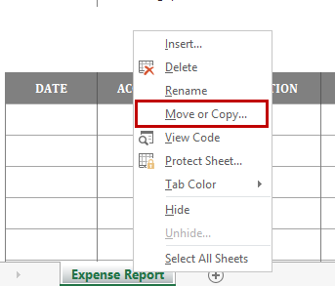

* 1. From the **Move or Copy** dialog, select **template.xlsx** in the **To book** drop-down list.
  2. Select the check box for **Create a copy** and click **OK**.

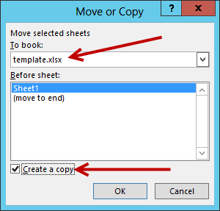

1. In the **template.xlsx** file, right-click on the **Sheet1** tab and select **Delete**.

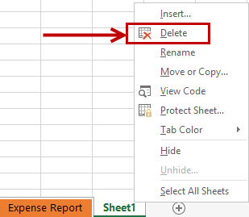

1. Save the **template.xlsx** file and then close the file.
2. Close the **Expense Report.xlsx** file and close **Excel**. Do not save changes to the Expense Report.xlsx file.
3. From the browser, navigate back to the root of the **Excel Documents** library.
4. From the **Files** tab of the **Excel Documents** library, expand the **New Document** **drop-down list and** click **New Document**.

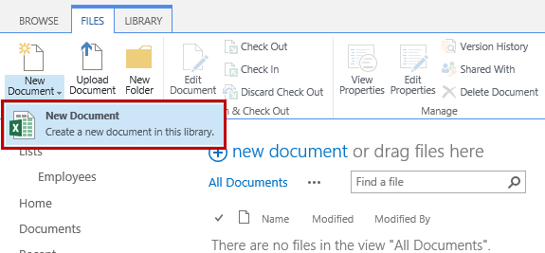

1. Excel will open using the updated template.xlsx file.

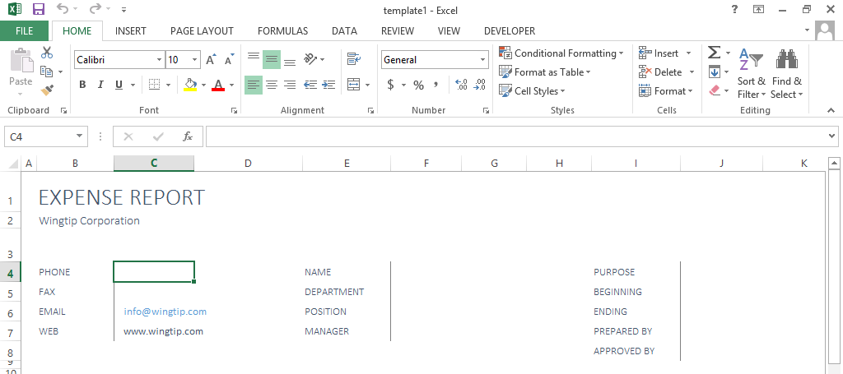

1. Update the contents of the file and once complete hit the **Save** icon at the top of Excel.
2. From the **Save As** panel, click on **Excel Documents** located under the **Current Folder** section.

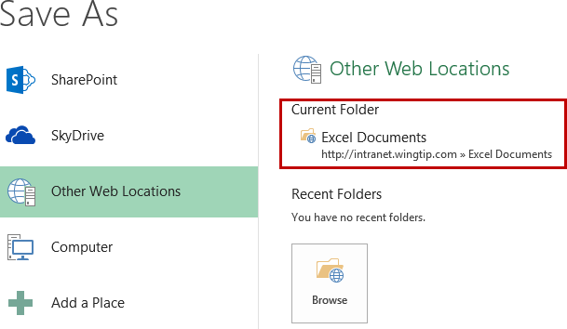

1. Update the **File name** and then click **Save**.

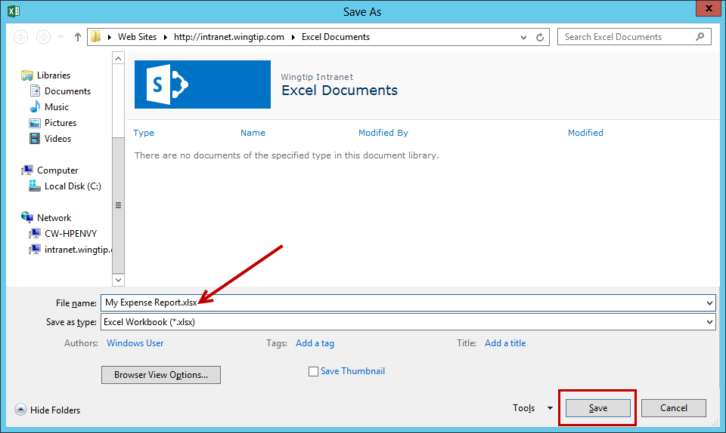

1. Close **Excel**.
2. From the browser, navigate back to the **Excel Documents** library and notice your new file has been saved.

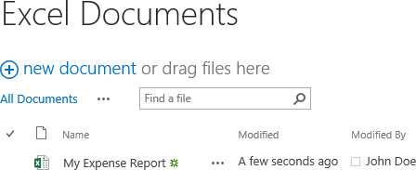

You have now completed this lab exercise.